THE UNIVERSITY OF CONNECTICUT
Systems Neuroscience
2012-2013

VOLUNTARY MOVEMENT

S. J. Potashner, Ph.D.
Lecture

Reading:
1. Purves, Chapter 17
2. This syllabus

GOALS
Although this lecture covers some structures mentioned in the textbook, it takes a different organizational approach. The lecture uses the most common of human movements, a visually guided movement, as a model to describe the sequence of events and activities in motor and sensory areas of the brain before and during the movement. Thus, the lecture attempts to provide an understanding of the elements that various brain areas contribute to a motor behavior and a guide to the order in which these contributions might be made.

A VISUALLY GUIDED MOVEMENT OF THE UPPER LIMB

DEFINITION OF MOVEMENT:
While standing in front of the open cooler in the cafeteria, you get a bottle of juice from a shelf at eye-level in the cooler and put it on your lunch tray.

STEP 1: See and recognize the bottle of juice in its environment (precedes movement).

Visual input is processed through primary visual cortex and passed into the inferior ‘what’ and superior ‘where’ visual streams (Fig. 1). In the ‘what’ stream, the inferior temporal association cortex, together with the occipito-temporal (fusiform) cortex, recognizes the object and communicates that information to the cingulate cortex and the prefrontal association cortex (PFAC). Spatial visual cues are passed into the superior visual stream. Spatial perceptions are synthesized in superior and inferior parietal association cortex and communicated to the cingulate cortex and PFAC.
Figure 1

STEP 2: Decide if the juice is wanted? (precedes movement)

The PFAC receives information from many cortical association areas and integrates this input to infer the context in which to place the newly received information. Inputs, such as those described in Figure 1, are integrated to decide if the recognized object is desired or undesired, of interest or not. Thus, lesions in the PFAC result in impaired contextual awareness, impaired decision making, impaired planning and changes in personality. When an object is of interest, i.e., worthy of attention, the PFAC ensures continuous activation of neurons in the posterior association areas that provide information to the PFAC (Fig. 2). This allows us to pay attention to the objects of interest and continue to form and analyze perceptions of them and of the environment around them. We will assume that the object is desired or of interest and that attention is focused on it.
Figure 2

STEP 3: Choose and develop a motor strategy to get the bottle of juice.

A. Acquire spatial relationships (precedes movement).
Using information from the superior (spatial) visual stream, the superior parietal cortex sends information to the PFAC about the location, orientation and size of the object. The superior parietal cortex together with the frontal eye fields activates gaze centers to direct gaze to the object. The superior parietal cortex also translates proprioceptive data representing the positions of the head, eyes, and upper limbs into excitations representing coordinates useful for motor actions. The inferior parietal cortex, integrates visually derived spatial cues about the object and somatosensory information about the positions of other body parts (Fig. 3). This integrated spatial information is sent to the PFAC to provide vectoral instructions to contribute to the activation of upper motor neurons. These excitations represent the intention to reach out and grasp the object of interest. These excitations are passed to the PFAC, which integrates these and other inputs. For example, the input from the cingulate cortex provides positive emotional excitation to help formulate the motor strategy. The input from the inferior (form) visual stream provides information about the identity of the object and other objects in its vicinity.
Figure 3
B. Develop a goal, a general motor strategy (precedes movement).
The postero-lateral part of the PFAC (see tips of long arrows in Fig. 3) holds (remembers) several elements of input information. This area of the PFAC is the center of a larger network of cortical association areas devoted to a type of short-term memory called ‘working memory’. Working memory has a low capacity (holds ~7-10 objects/relationships) and depends on the continuous activation and output of cortical neurons. The postero-lateral PFAC passes information more widely into the PFAC. Activation of cell groups in the PFAC results in the assembly of an appropriate motor goal and a general strategy to retrieve the juice bottle. For example, an appropriate strategy in the context of the cafeteria at a medical school might be to use the dominant upper limb to quietly reach out, grasp and retrieve the bottle. Lesions in the postero-lateral part of the PFAC result in deficits in holding (remembering) spatial information and other information required for constructing motor strategies. As a result, they produce apraxias, deficits in assembling appropriate motor strategies (i.e. wrong body parts used; sequence is inappropriate; components are missing; complete failure to construct strategies).

STEP 4. Activate upper motor neurons in motor cortical areas.
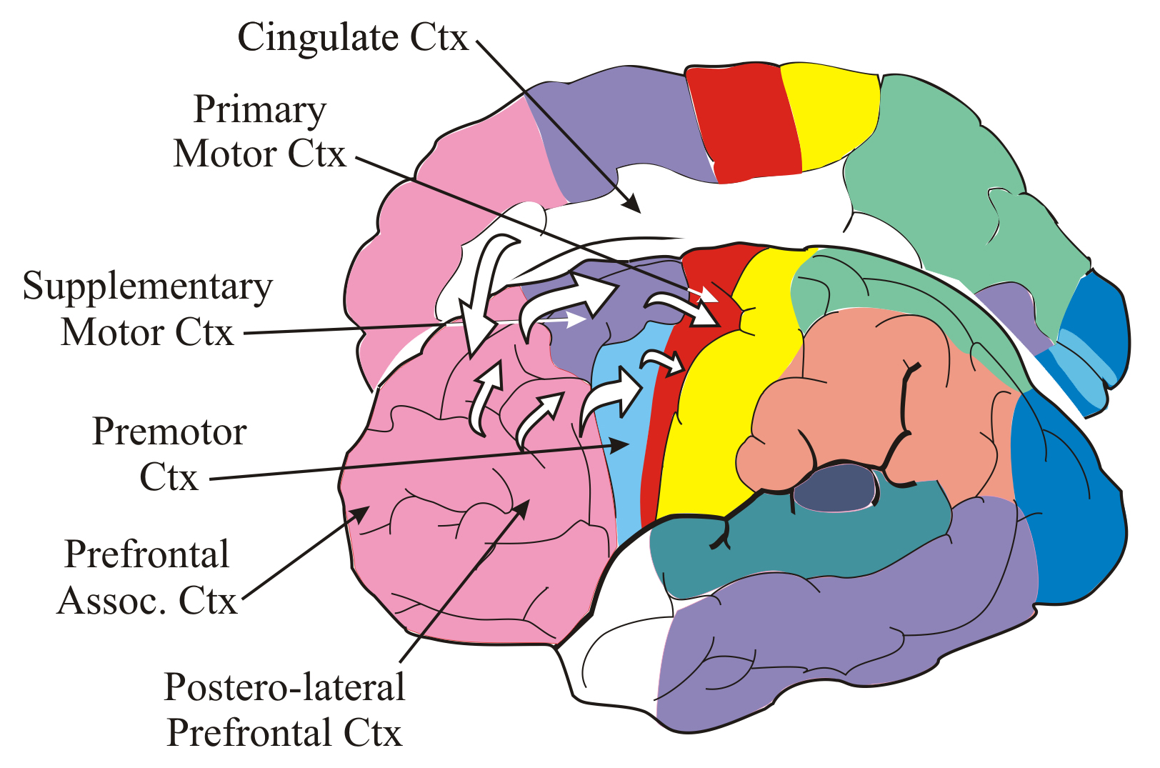
Similar to STEP 2 (in which the PFAC activated more posterior areas of association cortex), the PFAC can activate groups of upper motor neurons in motor cortical areas to implement the motor components of a behavior. Thus, the PFAC excites the topographically relevant areas of the supplementary motor cortex (SMC) and the premotor cortex (PMC).
Figure 4

A. The SMC contains upper motor neurons that primarily control the activation of other upper motor neurons in the primary motor cortex (M1). The SMC in each hemisphere is topographically organized and contains a bilateral map of the musculature. The synaptic connections among SMC cells group the neurons into networks each of which represents and controls a primitive movement component, such as reaching with an arm, retrieving with an arm, etc.; the synaptic strengths in these networks are controlled through practice and learning. Thus, excitation of cell groups in the SMC can result in the activation of one or more networks that, in turn, assemble a series of primitive movement components and order them over time. These movement components are assembled from a repertoire of learned motor movements. SMC cell groups are usually activated by the PFACs, in pursuit of a specific motor goal, or by self-motivated, spontaneous motor behaviors rather than by external stimuli.
In general, the SMC contributes components to motor behaviors that require movements of the head, face, extremities, locomotion, balance and especially the bilateral coordination of any of several body parts (i.e., playing the piano: trunk, neck, arms, eyes, 10 fingers, right foot, etc). In the present case (Fig. 4), we have not included specific locomotion, but SMC cell groups representing trunk and lower extremity muscles will be activated to balance the body during the behavior. Also, reaching for and retrieving the juice bottle requires sequential movements and coordination of both the upper extremities. Thus, the general strategy of the dominant arm reaching, that was synthesized in the PFAC, will activate the appropriate SMC cell groups representing the upper limb lower motor neurons (and muscles) that will be used to reach. At the same time, SMC cell groups representing the other upper extremity will be activated to hold the lunch tray in an appropriate position and cell groups representing muscles the balance the body will be activated. The activated SMC cells, in turn, pass excitation to the appropriate topographies in M1.

B. The PMC contributes to the activation of upper motor neurons in M1that orient movement components spatially (preceding & during movement).
The PMC in each hemisphere is topographically organized and contains a motor map of the contralateral musculature. The synaptic connections among PMC cells group the neurons into networks each of which represents and controls a movement component; the synaptic strengths in these networks are controlled through practice and learning.
The PMC contributes components of direction, orientation and position to components of motor movements involving the contralateral musculature, such as reaching or retraction movements of the extremities in specific directions; orientation of the forearm, wrist and hand; gripping objects of various shapes; leaning or turning of the head or body in specific directions, etc. In the present case (Fig. 4), reorientations of the head and body are probably unnecessary, but the dominant upper extremity should reach out to a specific location to acquire the bottle, the hand should be oriented to the shape of the bottle, grasp it, and then retract to retrieve it to a specific location. Thus, excitation of the upper extremity areas of the contralateral PMC would activate the appropriate M1 neurons to contribute signals influencing the direction, orientation and positioning of the limb components. PMC cell groups are usually activated by the PFAC, in pursuit of a specific motor goal, or by current input from other association cortices. Thus, PMC cells can receive excitation from posterior association cortices during a behavior that serves to further guide a movement that is in progress. The activated PMC cells, in turn, pass activation to the appropriate topographies in M1.

C. The primary motor cortex (M1) contributes to the activation of lower motor neurons (and muscle groups) by adding strength and direction to movement components (preceding & during movement).
M1 contains upper motor neurons that control lower (alpha) motor neurons and pre-motor interneurons in the brain stem and the spinal cord. In each hemisphere, it is topographically organized and contains a motor map of the contralateral musculature. The synaptic connections among M1 cell groups represent movement components, and their synaptic strengths are controlled by practice and learning.
M1 receives activation primarily from the SMC and the PMC (Fig. 4). M1 cells integrate the excitatory input from these two sources. Topographies activated in M1 are appropriate to the intended movement and result in the amplification of the excitatory drive by passing many trains of action potentials from M1 cells to the appropriate lower motor neurons and pre-motor interneurons. These action potential bursts activate the lower motor neurons. The frequency of the action potentials in the train encodes the strength and velocity of the ensuing muscle contractions. The particular conglomerate of M1 cell groups (topographies) that are activated determines the particular muscles that will contract and, thus, the direction of joint movement.

D. Lesions
Lesions of the SMC and the PMC result in apraxias without muscular weakness. After small lesions, some of the detailed movement components normally contributed by these areas may be absent. After large lesions, the motor strategies emanating from the PFAC may not be received or processed. For example, lesions in the SMC can result in a deficit in self-initiated, spontaneous motor behaviors, while PMC lesions can lead to deficits in motor behaviors initiated in response to external stimuli. Lesions in M1 cause weakness and spasticity in specific muscle groups without apraxia.

E.

The role of the association cortices
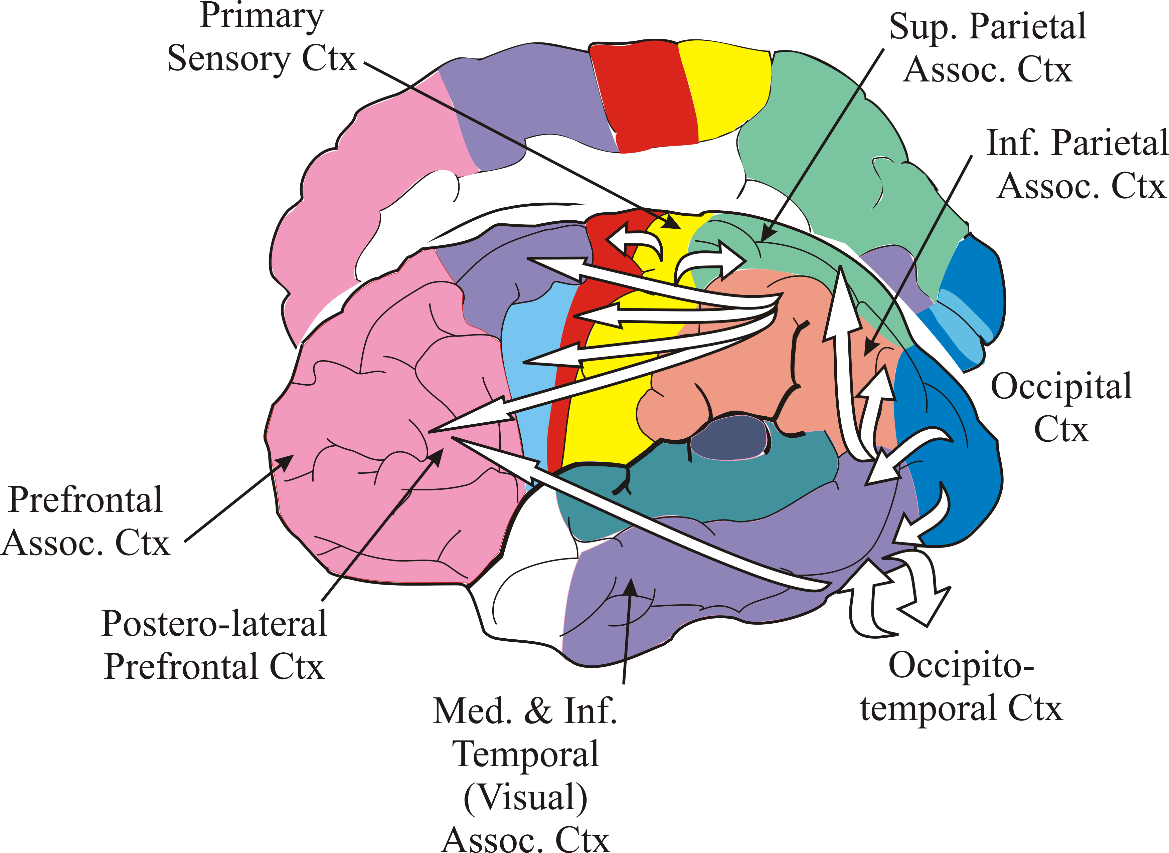
A vital element of any motor behavior is the continuous evaluation of the progress and quality of the motor movements via sensory input. Areas of the occipital, temporal and parietal association cortices that synthesize these features are kept active by the PFAC during motor behaviors (Fig. 5). Also active are the superior parietal cortex, to direct gaze; the left superior parietal cortex to translate visual and somatosensory perceptions in excitations guiding the upper extremities; the right inferior parietal cortex, to support construction of spatial perceptions and body movements; the left inferior parietal cortex, to manipulate objects in the environment; the inferior temporal cortex, to recognize visualized objects; the middle temporal cortex, to analyze object orientation and movement; etc. Information from these association cortices is passed to the PFAC and directly to the SMC, PMC and M1 (Fig. 5) so that refinements may be imposed on movement features.
Figure 5
The PFAC also activates the primary sensory cortex (S1) which, in turn, sends action potentials via descending projections to partially depolarize secondary sensory cell networks in the brain stem and the dorsal horn of the spinal cord. In fact, these S1 fibers descend as a component of the descending motor control pathways. The partially depolarized secondary sensory cells, therefore, are already nearer their firing threshold when they receive input from primary sensory fibers. This system ensures adequate monitoring of cutaneous and proprioceptive sensations that pertain to the movement (i.e. skin and muscle stretch at flexed joints, touch at relevant finger tips, joint angles and limb positions, etc). Sensory data generated by this system is passed up to S1, where some of it may be relayed directly to M1, to help modify control of the strength and direction of movements, or to the parietal association cortices (Fig. 5).
Lesions to the sensory structures that mediate somatosensory monitoring (e.g. spinal nerve sensory neuropathies) compromise the corrective control of motor functions and produce severe motor disorders. Loss of proprioception, for example, removes the capacity to sense the presence and position of body parts, joint orientation, the force generated by muscles, and the stretch of muscles loaded with weight. Loss of tactile sensation removes the capacity to sense contact with objects. Without these sensations, there is severe impairment of accuracy of movements, stabilizing the limbs in a desired position, manual dexterity, walking, etc. Visual monitoring of body parts compensates only partially for these deficits.

DESCENDING MOTOR PATHWAYS

INTRODUCTION
Tract: In the CNS, tracts carry information from one neural processing center to the next. A tract is defined as a group of neurons specified according to origin (location of the cell bodies) and destination (location of the axonal endings). The axons usually course together from the origin to the destination. A tract is usually named by stating its origin followed by its destination; sometimes other names are also used. For example, the cortico-spinal tract is the group of neurons with cell bodies in the cerebral cortex and axonal endings in the spinal cord. Any tract can be named by this formula with some degree of specificity. Hence, the fronto-spinal tract is the subset of cortico-spinal neurons originating in the cerebral cortex of the frontal lobe. The uncrossed cortico-spinal tract is the subset of cortico-spinal neurons ending on the same side of the CNS as they arise (ipsilateral or homolateral). The cortico-spinal tract is also called the pyramidal tract, since its fibers form the medullary pyramids. A tract is sometimes called a projection.

Fasciculus: A bundle of fibers, which may contain one or more tracts.

Pathway: 2 or more tracts that are connected successively in a chain. Pathways are a component of each functional system in the CNS.

Features: There are 7 key features which should be known for every motor tract, if possible.
1. Origin: according to nucleus or region of gray matter (ie. the neural processing center).
2. Course of the axons, with respect to cerebral subdivisions and location therein, and site(s) of any fibers crossing the midline (commissures).
3. Laterality: whether the axonal terminations are crossed, uncrossed, or bilateral with respect to the origin. Bilateral means both crossed and un-crossed, i.e., the axons of some neurons cross the midline before reaching their destination; axons of other neurons do not cross the midline but project to the corresponding destination on the same side; some neurons may send axon branches to both sides.
4. Destination of axonal endings, according to region of gray matter or nucleus, and, in some cases, types of neuron or target cell.
5. Topographical organization: Ordered, sequential, spatial representation in the CNS of the sensory receptor surface or the motor apparatus.
6. Function: Several points regarding the probable functional significance of the pathway, where this is known, and in some cases whether the synaptic activity of the tract is produces excitation or inhibition, its transmitter, whether the target cell activity is suppressed or facilitated. Obviously function depends a lot on the connections.
7. Dysfunction may have been defined previously in connection with sensory pathways. Although relevant to motor pathways, this feature is often more difficult to define for an individual descending motor tract, as pure lesions of single tracts are rare, while mixed lesions of several tracts are more common. For this reason, dysfunction will be considered in the context of known pathology or in the context of specific lesions, if such information is available.

AN ANATOMICAL OVERVIEW
The descending somatic motor tracts are the axons of upper motor neurons. They convey excitation to lower motor neurons and interneurons in the brain stem and the spinal cord. One view of these tracts places them in two groups based on the location of their fasciculi (bundles of fibers) in the spinal cord. First, the lateral pathways course in the lateral column of the spinal cord. They project most heavily to spinal neurons that control distal muscles of the limbs. They project less heavily to spinal neurons that control axial and proximal limb muscles. These pathways mainly provide descending motor signals for limb movements and some of the signals for axial muscles that control posture and locomotion. Second, the medial pathways course in the ventral column of the spinal cord. They project most heavily to spinal neurons that control axial and proximal limb muscles to provide descending motor signals for movements that control posture and locomotion. Using this view as an organizing principle, the descending tracts are described below.

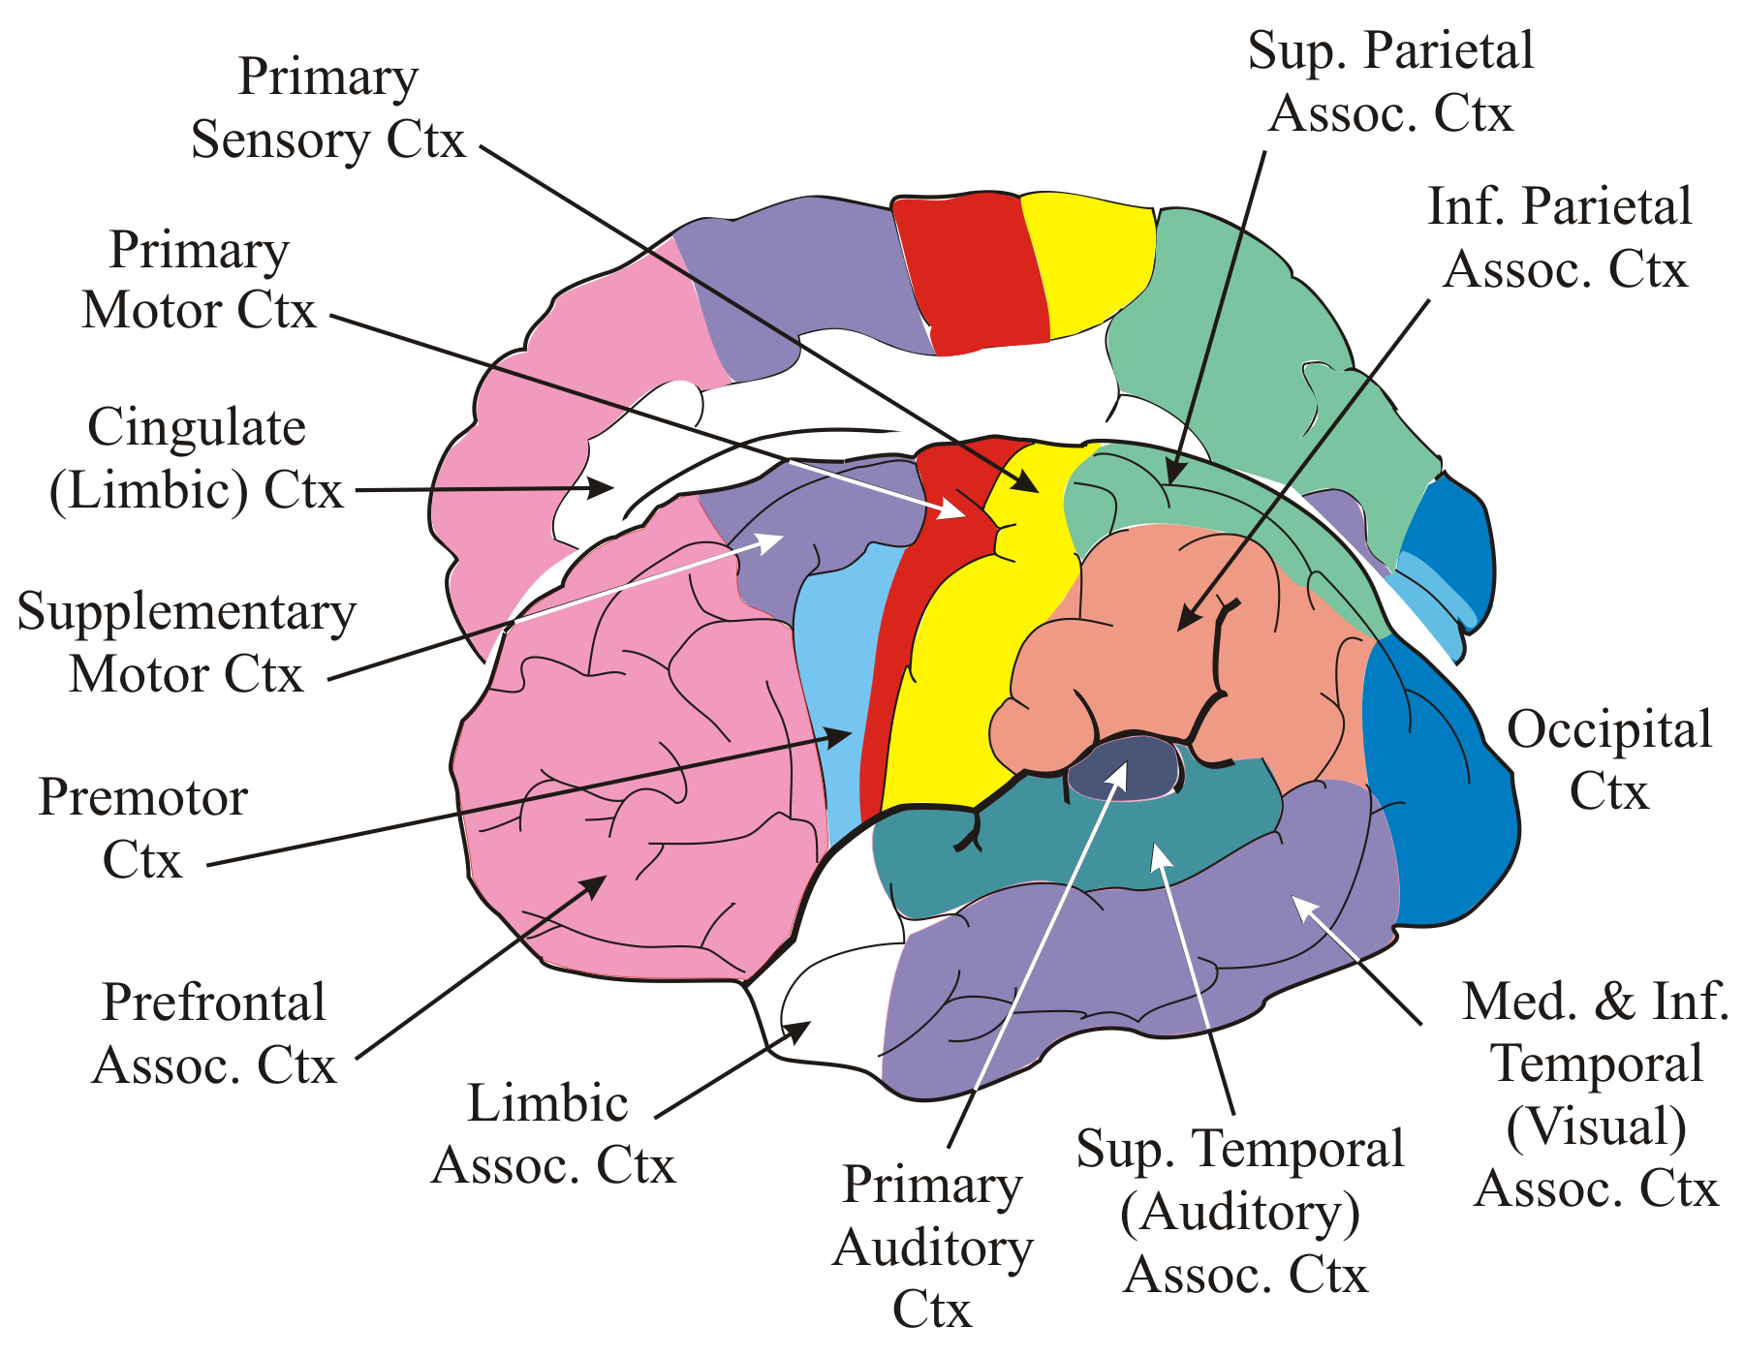
Figure 6

THE LATERAL PATHWAYS

A. The cortico-spinal (pyramidal) tracts
1. Origin: Predominantly from pyramidal cells in layer V of the motor areas and primary somatosensory cortex (S1) (Fig. 6). Approximately half of the fibers originate from primary motor cortex (M1); the remainder come from S1, PMC and SMC.
2. Course: Posterior limb of the internal capsule; middle region of the cerebral peduncle; through the pons. (A) In the pyramids, 75-95% of the fibers cross to the contralateral side in the decussation of the pyramids and descend in lateral column of spinal cord as the lateral cortico-spinal tract. (B) Fibers which do not cross in the decussation of the pyramids enter ventral column of the spinal cord as the ventral (anterior) cortico-spinal tract.
3. Laterality: (A) Lateral cortico-spinal tract = crossed. (B) Ventral cortico-spinal tract = primarily crossed, with a small uncrossed component (see Destination).
4. Destination: (A) The lateral cortico-spinal tract projects mainly to motor neuron nuclei in the lateral part of the ventral horn and to interneurons in the ventral horn, intermediate zone and in the base of the dorsal horn. The fibers originating in the motor cortical areas are those projecting to the lateral ventral horn and intermediate zone, with the heaviest projections to motor neuron nuclei controlling distal musculature and flexors. The fibers originating in S1 project to the dorsal horn. (B) The ventral (anterior) cortico-spinal tract projects bilaterally to the ventromedial cell columns in the ventral horn, which control proximal and axial muscles, and to adjacent areas of the intermediate gray. Most of these fibers cross to the contralateral side before synapsing in the spinal gray.
5. Topographical organization: Topographical (somatotopic) organization.
6. Function: Cortico-spinal neurons are excitatory and use glutamate as their transmitter. The motor component is a monosynaptic pathway from motor cortical areas (Fig. 6) to the spinal (lower) alpha-motor neurons and pre-motor interneurons. The tract influences gamma-motor neurons indirectly, via interneurons. Since at least half the fibers originate in M1, they carry the signals coding the strength and direction of movements; the function of the remaining fibers that originate in motor areas is unknown. Thus, much of the tract mediates motor actions and helps to control muscle tone and influence spinal reflexes. This tract especially provides rapid responsive fractional movements mediated mainly by distal limb muscles and a high degree of dexterity, especially in the upper limb.
The cortico-spinal tract appears to be the only descending motor tract that mediates ‘differential’ or ‘fractional’ movements in certain muscles. Differential or fractional movements are defined as distinct movements resulting from the activation of only part of a single muscle. For example, the flexor digitorum superficialis muscle flexes the four proximal interphalageal joints. But activation of part of the muscle results in independent flexion of each one of the fingers. Apparently, this fractional activation requires the intact cortico-spinal tract. Fractional activation is possible because a proportion of the cortico-spinal axons synapse directly on lower motor neurons, thus allowing the motor cortex to choose which group of lower motor neurons inside the spinal motor neuron nucleus (i.e., which part of the muscle) to activate.
The component of fibers from S1 is a monosynaptic pathway from the primary somatosensory cortex to secondary sensory neurons in the dorsal horn. These fibers influence sensory processing associated with movements.
7. Dysfunction: Pure lesions of the cortico-spinal tract result in contralateral weakness, or loss of function (paresis) and the appearance of abnormal reflexes, such as forced grasping and decreased magnitude of stretch reflexes, and sign of Babinski. Pure lesions almost never occur in human disease. Usually the clinical picture is complicated by spastic paresis and lesions of the cortico-subcortical tracts, which originate from the same regions of the cortex as the cortico-spinal tract and also course in the internal capsule. Spastic paresis is a phrase used to indicate weakness or paralysis in which an excess of muscle tone produces the continuous, relentless contraction of upper limb flexors and lower limb extensors. The reasons for the spasticity are not clearly understood.

B. The cortico-bulbar tracts
1. Origin: Pyramidal cells in layer V in and near the representation of the head in M1, PMC and SMC; in and near the representation of the head in S1; the frontal eye fields in the frontal cortex (Fig. 6).
2. Course: through the genu of the internal capsule; middle region of the cerebral peduncle.
3. Laterality: Bilateral, with 4 exceptions. Cortical fibers mostly cross before they synapse on motor and inter-neurons in the facial nucleus that control the muscles of the lower face. Similarly, mainly crossed cortical projections synapse in the nucleus ambiguus and hypoglossal nucleus. Cortical fibers projecting to the spinal accessory nucleus are mainly uncrossed.
4. Destination: Fibers synapse on interneurons and motor neurons of the cranial nerve nuclei and on adjacent reticular interneurons. Fibers from regions representing the head in the somatosensory cortex also synapse on neurons in the cuneate and the sensory trigeminal nuclei.
5. Topographical organization: Topographically organized.
6. Function: Fibers projecting to the motor nuclei provide for upper motor neuron activation of cranial nerve motor nuclei. Fibers projecting to sensory nuclei influence sensory processing of motor-related information (see discussion of cortico-spinal tract functions, above).
Dysfunction: see cortico-spinal tract.

C. The cortico-rubro-spinal pathway
In humans, the cerebellum is the main destination of cortico-rubral pathways. The cortico-rubro-spinal pathway is a minor pathway in man, which consists of 2 tracts: the cortico-rubral and the rubro-spinal tracts.
I. The cortico-rubral tract
1. Origin: Similar to the cortico-spinal tract.
2. Course: Through the posterior limb of the internal capsule to the red nucleus.
3. Laterality: Uncrossed
4. Destination: Neurons of the red nucleus

5. Topographical organization: Somatotopically organized
6. Function: Cortico-rubral neurons are excitatory and use glutamate as a transmitter. They are thought to synapse directly on the neurons of the red nucleus. They convey the motor output of the cortex to the red nucleus. Since the red nucleus also receives considerable input from the deep cerebellar nuclei, the red nucleus integrates cortical motor commands and cerebellar coordination commands.
II. The rubro-spinal tract
1. Origin: The large cells of the red nucleus.
2. Course: After decussating in the rubro-spinal commissure (in the ventral midbrain, just as the fibers emerge from the red nucleus), rubral fibers descend laterally in the brain stem tegmentum, ventral to the spinal trigeminal tract, and descend in the lateral column of spinal cord just ventral to the lateral cortico-spinal tract.
3. Laterality: Crossed.
4. Destination: Pre-motor interneurons in the same areas of the spinal gray matter that receive cortico-spinal tract fibers. Most rubro-spinal fibers terminate in the upper regions of the spinal cord, innervating interneurons that help to control the muscles in the upper extremities.
5. Topographical organization: Somatotopically organized.
6. Function: Rubro-spinal neurons are excitatory and use glutamate as a transmitter. The tract does not innervate motor neurons but contacts pre-motor interneurons, which control groups of distal and proximal limb muscles and axial muscles. In control of distal limb muscles, it contacts pre-motor interneurons which assist the cortico-spinal tract. However, the rubro-spinal tract cannot provide fractional or differential movements, as it does not synapse directly on lower motor neurons. The rubro-spinal tract generally facilitates flexor motor neurons and inhibits some extensor motor neurons.
7. Dysfunction: Lesions produce contralateral tremor, ataxia, chorea, all of which resolve over time.

THE MEDIAL PATHWAYS

A. The cortico-reticulo-spinal pathway
This pathway consists of the cortico-reticular tracts and two reticulo-spinal tracts.
I. The cortico-reticular tracts

1. Origin: Mainly in the sensori-motor cortex, with some fibers from other widespread regions of the cerebral cortex, including the frontal, parietal, temporal, and occipital association cortices (Fig. 6).
2. Course: Through the posterior limb of the internal capsule; the cerebral peduncles.
3. Laterality: Bilateral, but the predominant laterality of each of these tracts is organized with respect to its corresponding reticulo-spinal tract, so that the overall output of this pathway is predominantly crossed.
4. Destination: Nuclei in the pontine and medullary reticular formation.
5. Topographical organization: Poor topographical organization
6. Function: Cortico-reticular fibers may use glutamate as an excitatory transmitter. However, they both excite and suppress reticulo-spinal activity; suppression is thought to be mediated through inhibitory reticular interneurons (see IV below).
II. The medial (pontine) reticulo-spinal tract
1. Origin: The pontine reticular formation
2. Course: Through the ventral reticular formation of the medulla; the ventral column (medially) of the spinal cord.
3. Laterality: Predominantly uncrossed
4. Destination: The alpha- and gamma-motor neurons and especially the interneurons in motor nuclei in the medial region of ventral horn and in the intermediate gray of the spinal cord.
5. Topographical organization: No somatotopic organization
6. Function: Generally facilitates muscle contractions in adjustments of posture and locomotion. Acts mainly on axial muscles and proximal limb extensors (see IV below).
III. The lateral (medullary) reticulo-spinal tract
1. Origin: The medullary reticular formation
2. Course: Through bulbar (medullary) commissures; lateral column of spinal cord
3. Laterality: Bilateral
4. Destination: Interneurons throughout the intermediate gray of the spinal cord.
5. Topographical organization: No somatotopic organization.
6. Function: Generally suppresses muscle contractions in adjustments of posture and locomotion. Acts mainly on axial and proximal limb muscles.
IV. Functions of the cortico-reticulo-spinal pathway. This pathway functions in locomotion and in the control of posture, spinal reflexes, and muscle tone. Locomotion and postural adjustments require the coordinated bilateral control of axial and proximal limb muscles. Often, axial muscles must contract on one side of the body while other axial muscles must simultaneously relax. These two actions are controlled by the simultaneous activation of the pontine and medullary reticulo-spinal tracts.

B. The vestibulo-spinal tracts
These tracts operate mainly under the control of the vestibular system, cerebellum, and reticular formation.
I. The lateral vestibulo-spinal tract
1. Origin: Neurons of the lateral vestibular nucleus.
2. Course: Descends laterally in the brain stem tegmentum through the ventral column of spinal cord.
3. Laterality: Uncrossed
4. Destination: Projects to all levels of spinal cord. Synapses on alpha- and gamma-motor neurons in the medial region of ventral horn, and on interneurons in the intermediate gray and in the ventral horn.

5. Topographical organization: Topographical
6. Function: These fibers are excitatory, may use glutamate as a transmitter. They help to mediate postural adjustments of the body and limbs in response to changes of head position (postural labyrinthine reflexes). They generally facilitate extensors and inhibit flexors via inhibitory interneurons.
II. The medial vestibulo-spinal tract
1. Origin: The medial vestibular nucleus.
2. Course: Some of the fibers cross through a commissure in the medulla. All the fibers descend in the medial longitudinal fasciculus (MLF) through the medulla and in the ventral column of spinal cord.
3. Laterality: Bilateral
4. Destination: The fibers project to cervical and upper thoracic levels of the spinal cord. They synapse on motor neurons and interneurons in medial regions of ventral horn and in the intermediate gray.
5. Topographical organization: Probably topographically organized
6. Function: Helps to mediate postural adjustments of the neck in response to changes in head position (postural labyrinthine reflexes).

