THE UNIVERSITY OF CONNECTICUT
Systems Neuroscience
2012-2013

The Hypothalamus

Lecture
S. J. Potashner, Ph.D.
(sjp9713@neuron.uchc.edu)

Reading
1. Purves, Chapter 21, pp. 528-530
2. This syllabus

Overview

The hypothalamus is a small structure located inferior to the anterior half of the thalamus, and it forms the walls and floor of the 3rd ventricle in that region (Fig. 1). The hypothalamus allows us to survive and reproduce. It responds to information from both internal and external environments by coordinating physiological processes and behaviors that help us to maintain our homeostasis (Box 1). The hypothalamus does this by acting on three systems: the autonomic nervous system, the endocrine system, and the motivational parts of the limbic system.
Box 1
Homeostasis is a collection of physiological processes and behaviors that keep the body’s internal environment either steady or within restricted limits. The hypothalamus, together with other areas of the nervous system, anticipate perturbations of the internal environment by using sensory stimuli to activate homeostatic mechanisms on a continuum of time scales. For example…
  - Immediate: sight or smell of food, intention to stand up, thermoregulation.
  - Daily: circadian rhythm organizes ingestion, digestion, hormone secretion, sleep.
  - Seasonal: body temperature control, nutrition adjustments.
Homeostatic responses depend on all parts of the nervous system, including sensory, somatic motor and autonomic (visceromotor) systems.

Neuroanatomy

Location and Boundaries: The hypothalamus is located inferior to the anterior half of the thalamus, and it forms the walls and floor of the inferior part of the 3rd ventricle in that region (Fig. 1). Its boundaries include: the hypothalamic sulcus, superiorly; the lamina terminalis, rostrally; the basal forebrain and internal capsule, laterally; the 3rd ventricle, medially; and the caudal edge of the mammillary body, caudally. Inferiorly, the hypothalamus forms the base of the diencephalon and is continuous with the pituitary, to which it is joined by the infundibulum and the pituitary stalk. The pituitary is divided into anterior and posterior lobes.
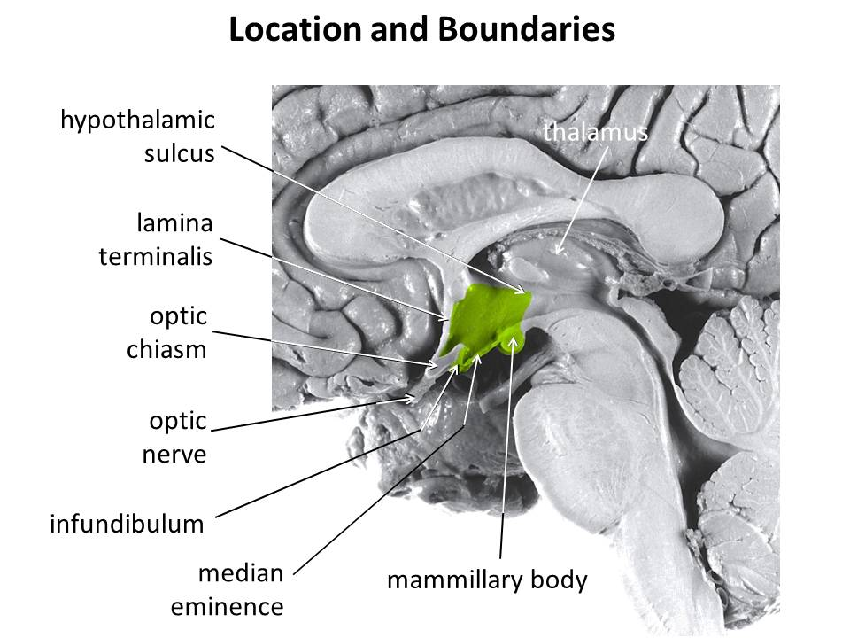
Fig. 1. Hypothalamus
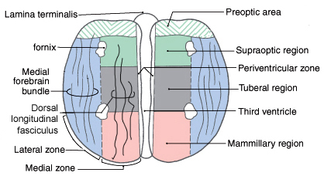
Divisions: Based on its cellular organization, the hypothalamus can be divided medio-laterally into three zones, each of which extends roughly throughout the rostro-caudal length of the hypothalamus (Fig. 2). When viewed in horizontal sections, the most medial zone is the periventricular zone, consisting of a thin sheet of neurons lateral to the 3rd ventricle. Next, the medial zone is adjacent (lateral) to the periventricular zone, and is organized into a series of distinct nuclei. In the rostro-caudal direction, the medial zone can be subdivided into the preoptic, supraoptic (also called chiasmatic or anterior), tuberal, and mammillary regions. Each region contains several nuclei (Fig. 4). Finally, the lateral zone is a diffuse collection of neurons considered by some authors to be an extension of the reticular formation (RF) of the brain stem.
Fig. 2. Horizontal section showing the rostro-caudal organization of the hypothalamus. Rostral = top. Midline is vertical in the center.

Axonal connections: Although axonal projections interconnect many of the hypothalamic nuclei to one another and connect the hypothalamus to many parts of the nervous system, we will consider only five main connection networks.
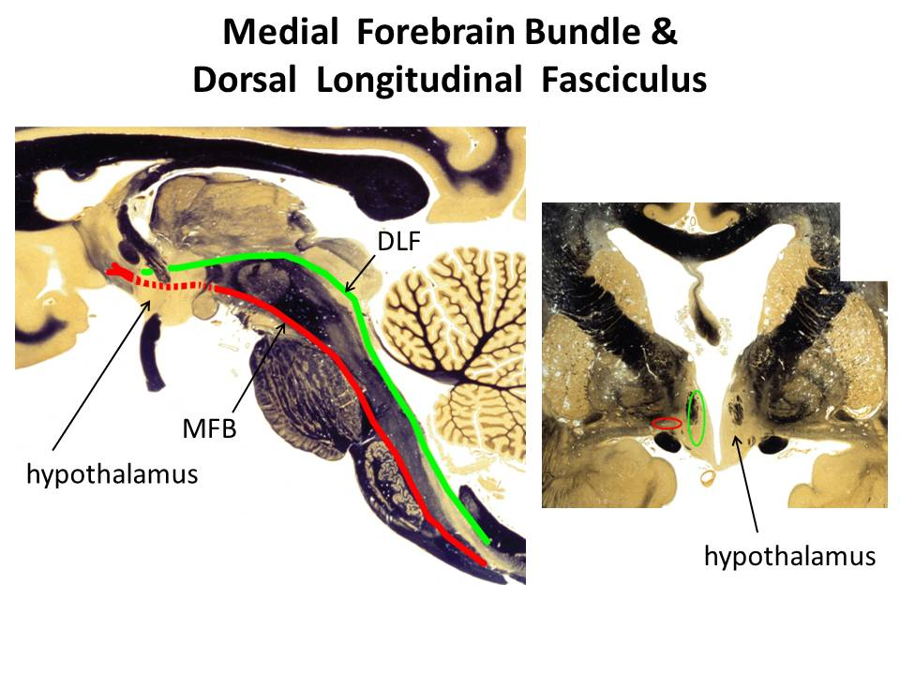
- The hypothalamus receives a variety of sensory information via afferent axonal input from collateral branches of somatic sensory, visceral sensory, and taste pathways that carry information initially into the brain stem RF. Brain stem RF cells, in turn, relay these signals into the hypothalamus via axonal projections that lie in two bundles: the median forebrain bundle (MFB) and the dorsal longitudinal fasciculus (DLF) (Fig. 2-3). The rostral end of the MFB also carries collateral axonal branches from the olfactory pathway directly into the hypothalamus. The MFB and DLF may be viewed as two bidirectional highways, as they also carry hypothalamic efferent axons that descend to the brain stem RF and the spinal cord. These axons carry hypothalamic signals to the brain stem RF and to the parasympathetic and sympathetic nuclei throughout the brain stem and spinal cord. Reticulobulbar and reticulospinal spinal tracts, in turn, relay hypothalamic signals from the RF to the somatic motor nuclei in the brain stem and spinal cord. These efferent hypothalamic pathways allow the hypothalamus to organize activities in the visceral and somatic motor systems.
Fig. 3. The locations of the medial forebrain bundle and the dorsal longitudinal fasciculus. The left panel is a paramedical section of the human brain while the right is a frontal section posterior to the optic chiasm and anterior to the mammillary body.

- The supraoptic area of the hypothalamus receives signals from retinal ganglion cells which project their axons into the optic chiasm and the pregeniculate nucleus (primate) or the ventral LGN (non-primates) of the thalamus. Both the optic chiasm and these thalamic nuclei signal to the suprachiasmatic nucleus (SCN) in the supraoptic area, a region that contains a circadian clock. This pathway carries signals representing the presence of light to help regulate our circadian cycles to correspond to day and night in the external environment.

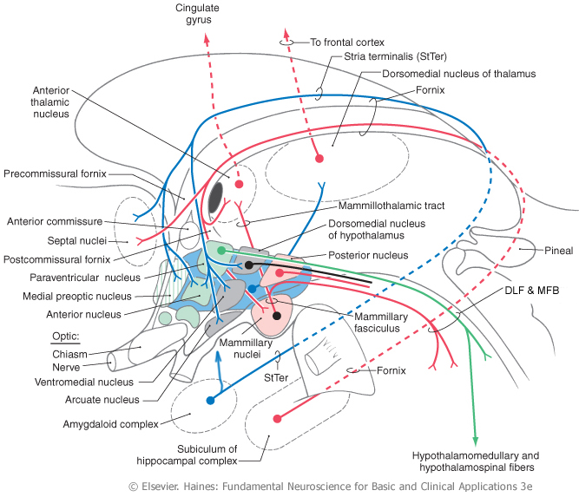
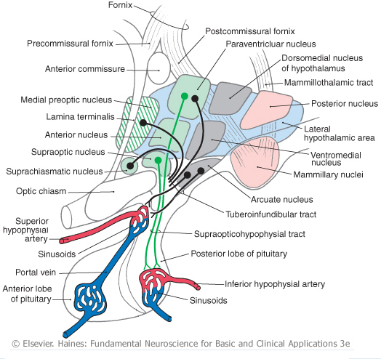
- The hypothalamus receives some cognitive information representing out emotional state via afferent axonal input from the limbic system, primarily from the hippocampus and the amygdala. Hippocampal signals arrive on hippocampal axons lying in the fornix, which synapse in the mammillary body (Figs. 4 & 5). Afferents from the amygdala lie in two pathways: the stria terminalis and the ventral amygdalar pathway (Fig. 5). The latter leaves the temporal lobe medially, courses medially through the basal forebrain, and enters the hypothalamus laterally. Again, these pathways may be viewed as bidirectional highways, as they also carry hypothalamic efferent axons that synapse in the hippocampus and the amygdala.
Fig. 4. Sagittal section through the medial zone of the hypothalamus and the pituitary. Colors correspond to those of the zones in Fig. 2. Rostral = left; Caudal = right; Superior = top.

- The hypothalamus receives additional cognitive information representing our emotional state via afferent axonal input from the cingulate and medial prefrontal cortex via anterior fibers that enter the lateral zone of the hypothalamus. The hypothalamus can influence our emotional state via efferent axons from the mammillary body project to the anterior nucleus of the thalamus (Figs. 4 & 5) which, in turn, projects axons to the cingulate cortex. The hypothalamus directly influences behavior via efferents from the lateral zone which project to the dorsomedial nucleus of the thalamus that, in turn, projects to much of the frontal cortex (Fig. 5).
Fig. 5. Inputs from the amygdala and hippocampus. Outputs to the brain stem, spinal cord and thalamus.

- Intrinsic to the hypothalamus, two pathways descend from the hypothalamic nuclei to the pituitary and control pituitary glandular secretions (Fig. 4).
- Neurons in two of the nuclei in the supraoptic area, the supraoptic and paraventricular nuclei, project their axons into the posterior pituitary via the supraoptic-hypophyseal tract. The cell bodies of these neurons synthesize either oxytocin or antidiuretic hormone (ADH, vasopressin) and transport the hormone anterogradely to their axon terminals in the posterior pituitary, where it is released into the blood stream.
- Neurons in the arcuate nucleus of the tuberal region and several other nuclei in the preoptic and supraoptic regions project their axons into the infundibular region of the hypothalamus via the tubero-infundibular tract. These axons convey various ‘releasing hormones’ which are secreted into the blood stream of a capillary plexus located inside the infundibulum. This capillary plexus is drained by small portal veins which carry the blood directly into a second capillary plexus inside the glandular tissue of the anterior lobe of the pituitary. Here, the hypothalamic releasing hormones come into contact with the hormone-producing glandular cells of the anterior pituitary and control their release of pituitary hormones to the blood stream. Through these pathways, the hypothalamus can control several peripheral organ systems.

Functions

The hypothalamus is essential for the survival of an organism and the reproduction of its species. It integrates and controls homeostatic responses and behaviors; many visceral reactions in response to changes in the external environment; and the reproductive physiology and behavior of an organism.

Circulatory dynamics: The hypothalamus maintains homeostasis of the blood circulation by regulating cardiac output, vasomotor tone, blood osmolarity, renal clearance, salt intake, and drinking behavior. For example…
- Blood osmolarity is kept constant by hypothalamic reflexes and non-reflex hypothalamic activity. In the reflexes, blood osmolarity is monitored by osmolarity-sensitve sensory neurons in several of the the circumventricular organs (Box 2). These neurons project their axons into the supraoptic and paraventricular nuclei, the origins of the supraoptic-hypophyseal tract (Fig. 4). When blood osmolarity is too high (large salt load or dehydrated), activity is generated in the supraoptic-hypophyseal tract, which releases ADH from the posterior pituitary into the general circulation and results in increased water reabsorption in the kidney. In severe dehydration, high levels of ADH secretion will also constrict blood vessels and increase blood pressure. In addition, the hypothalamus will generate non-reflex activity to provoke thirst, a behavior which may be defined as a strong motivation to seek, obtain and consume water. The neural pathways underlying hypothalamic induced thirst are not known. By contrast, if osmolarity is too low, the ADH secreting pathway is inhibited and activity is generated in oxytocin secreting neurons. Oxytocin secretion results in less reabsorption of water from the urine and an inhibition of thirst behavior.
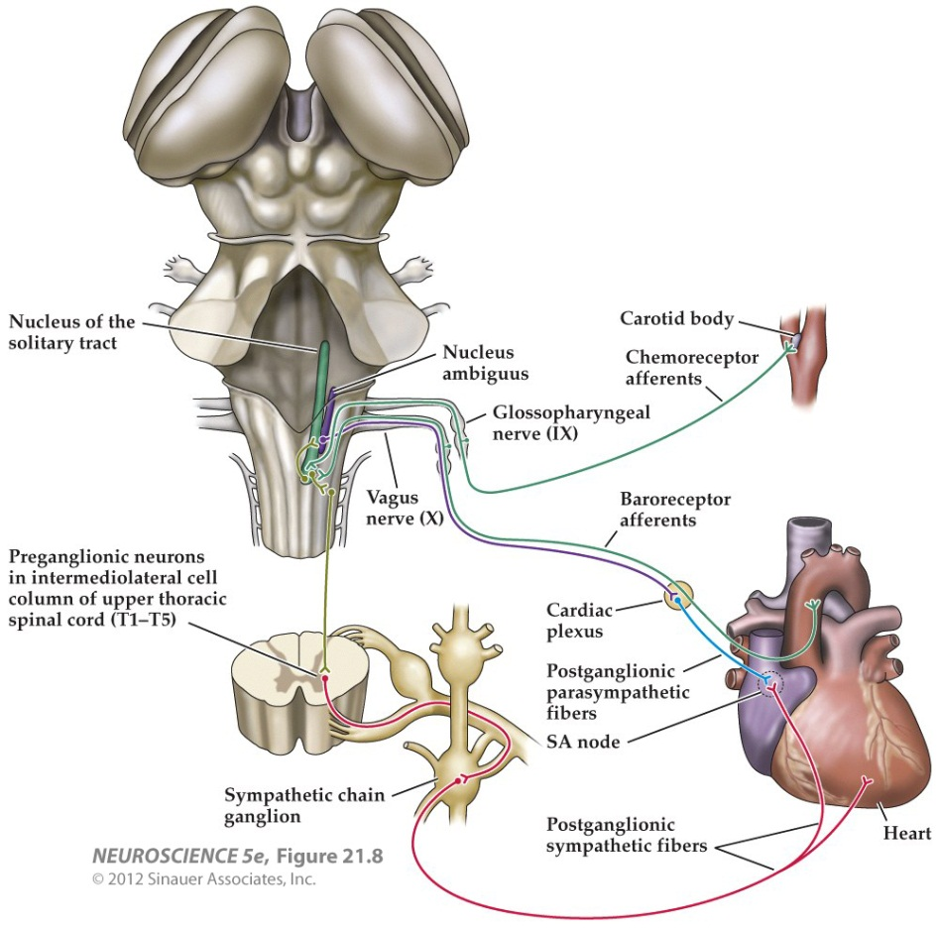
- Blood volume and pressure are kept constant by similar mechanisms. Sensations reflecting blood volume and pressure are generated by stretch receptors lying in the walls of the left atrium of the heart, the pulmonary arteries, and the aortic arch. In addition, chemorecetoprs in the carotid sinus are sensitive to levels of oxygen and carbon dioxide in the blood. All these sensory neurons project their axons into the caudal part of the solitary nucleus (NTS) in the medulla. The signals reaching the NTS are sent to two destinations. First, they are used to modulate a baro-reflex (Fig. 6). Copies of the signals reaching the NTS are sent to the nucleus ambiguous and the RF in the medulla. Vagus motor neurons in the nucleus ambiguus project to the heart and decrease the heart rate. RF neurons project to spinal autonomic neurons which increase the heart rate and induce blood vessel constriction. Second, NTS neurons send axons via the DLF and MFB to the paraventricular nucleus in the hypothalamus and influence ADH and oxytocin secretion.

Fig. 6. The baro-reflex.

- In addition, blood pressure and heart rate can be controlled by the hypothalamus via the autonomic nervous system. Some of the paraventricular nucleus neurons project their axons via the MFB and DLF to the motor and premotor neurons involved in the baro-reflex, as well as to autonomic neurons in the brain stem and spinal cord. Activity in this pathway lowers or raises blood pressure by controlling heart rate and blood vessel constriction, possibly in a regional pattern if required. In addition, axonal connections projecting from the supraoptic region of the hypothalamus to the hypothalamic areas listed in A - C (above) provide a circadian rhythm of blood pressure, which is lower at night and higher by morning.

Box 2
Eight small regions of the brain lack a blood-brain barrier (BBB) (see figure below) and can exchange signaling and other molecules with the blood. Since these regions are located on the boundaries of the 3rd and 4th ventricles, they are called circumventricular organs and are regarded as points of communication between the blood and the CNS. Three of them lie within the hypothalamus. Neurons at the base of the lamina terminalis form the vascular organ of the lamina terminalis (OVLT), which is sensory, as the cells are sensitive to the osmolarity of the blood and to blood angiotensin II levels (see below) and project their axons into hypothalamic nuclei. Neurons and glandular cells in the infundibulum and pituitary stalk (plus median eminence), as well as neurons in the posterior pituitary, are secretory circumventricular organs, as they secrete releasing hormones, ADH and oxytocin into the blood. Two additional sensory circumventricular organs are located outside the hypothalamus and project axons into the hypothalamus. The subfornical organ (SFO) lies in the roof of the 3rd ventricle under the fornix. Like the OVLT, it contains neurons that are sensitive to blood osmolarity and angiotensin II levels. The area postrema, located in the midline at the caudal end of the 4th ventricle, contains neurons that are sensitive to blood angiotensin II levels.

Angiotensin II is a potent vasoconstrictor. Its blood levels are regulated by sympathetic activity and by vascular endothelial cells in the lung and kidney.
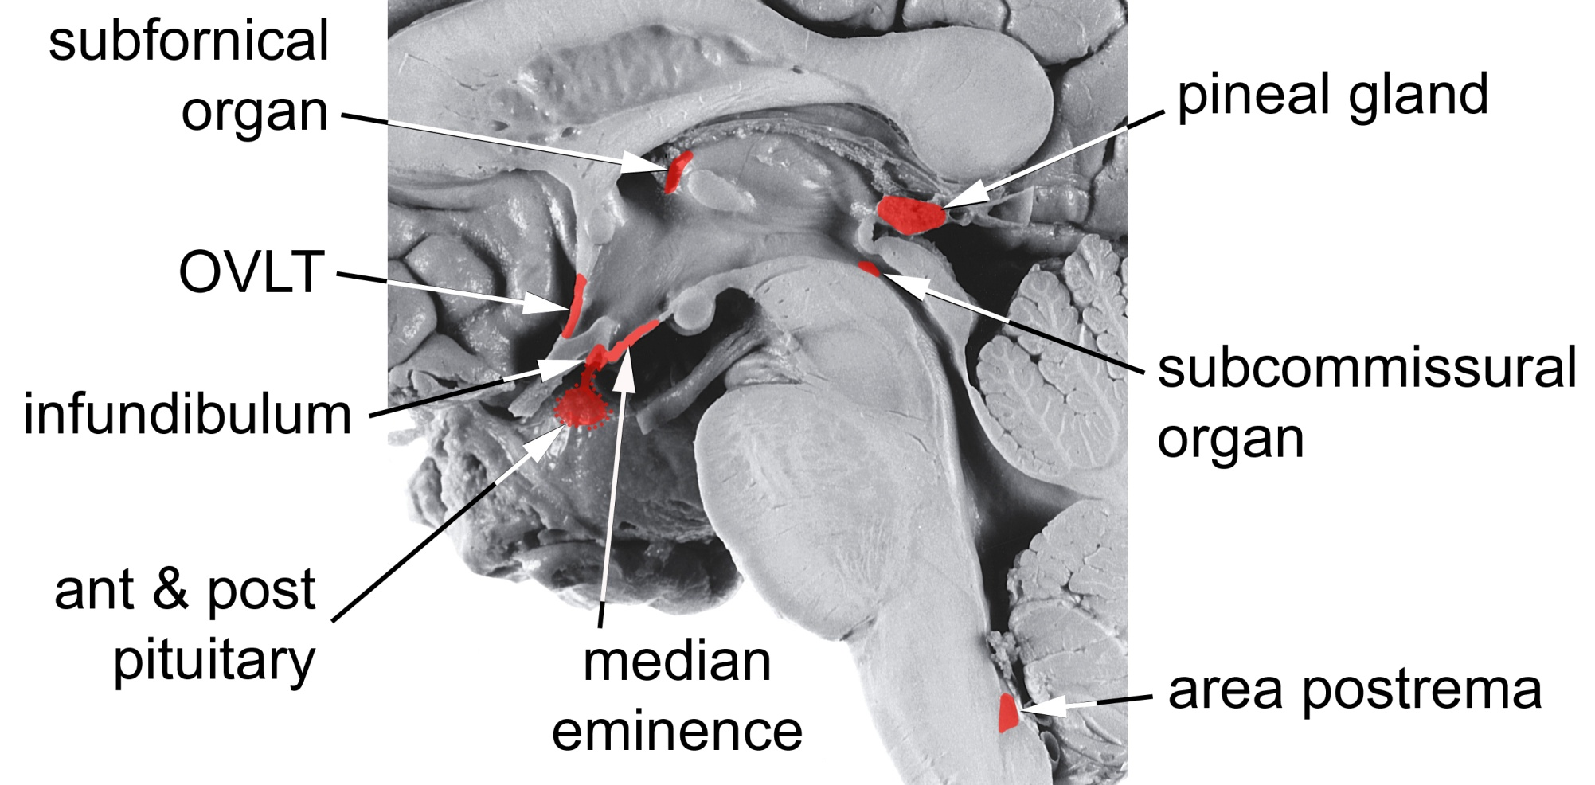

Energy Metabolism: The hypotahalmus regulates energy metabolism by monitoring blood glucose levels and regulating feeding behavior, digestive functions, metabolic rate and body temperature. For example …
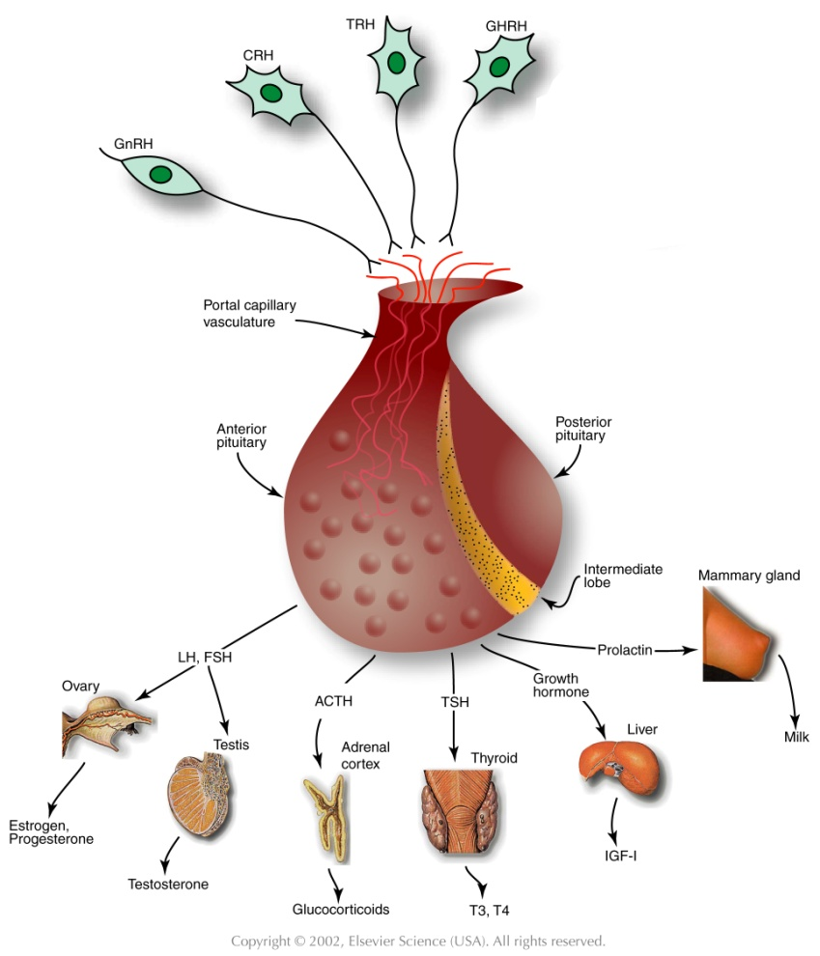
- Cellular metabolism throughout the body tissues is regulated via thyroid hormones. Neurons in the paraventricular nucleus in the supraoptic region of the hypothalamus secrete thyrotropin-releasing hormone (TRH) from axonal endings into the portal circulation of the infundibulum (Fig. 7). TRH is carried in the portal blood circulation to the anterior pituitary where it stimulates the release of thyroid-stimulating hormone (TSH) into the general circulation. TSH acts in the thyroid gland to stimulate the secretion of thyroxine (T4) and tri-iodo-thyronine (T3), which are released into the general circulation. These hormones promote energy metabolism, protein and complex lipid synthesis, etc., in virtually all cells. Thyroid hormones also inhibit the activities of TRH secreting neurons in the paraventricular nucleus of the hypothalamus and of TSH secreting cells in the anterior pituitary.
Fig. 7. Hypothalamus-pituitary-organ systems.

- Feeding provides nutrients, which are substrates for cellular metabolism. The neural regulation of feeding behavior is not well understood, although it is known to be controlled in both the short and long term.
In the long term, the set point for feeding behavior is established by the hypothalamus, although all the factors in feeding behavior are thought to be regulated by the combined activities of the limbic system, hypothalamus, NTS and area posterma. For example, the amount of body fat and glucose is signaled to the hypothalamus by leptin and insulin, hormones released from adipose tissue and the pancreas, respectively. These signals are transported through the BBB into the arcuate nucleus in the tuberal region of the hypothalamus.
One population of arcuate neurons is activated by leptin and insulin (excess body fat). These neurons, in turn, project axons to and activate neurons in the paraventricular nucleus in the supraoptic region of the hypothalamus (Fig. 8, black). These cells release oxytocin from the posterior pituitary (Fig. 4) and corticotropin releasing hormone (CRH) from the infundibulum (Fig. 7). The latter ultimately leads to cortisol release from the adrenal glands. The combination of oxytocin and cortisol are powerful catabolic signals that reduce food intake and increase energy expenditure with the result that body fat is reduced.
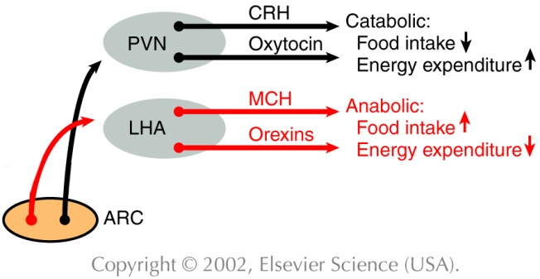
A second population of arcuate neurons is inhibited by leptin and insulin but they become activated when the levels of these hormones are low (insufficient body fat). These cells project axons to neurons in the lateral hypothalamic area (Fig. 8, red). Lateral hypothalamic neurons secrete orexins and melanin-concentrating hormone (MCH) via projections terminating in various brain regions. This activity constitutes an anabolic signal and leads to increased food intake and a reduction in energy expenditure with the result that body fat is increased.
Fig. 8. Hypothalamic influence on caloric homeostasis.

In the short term, meal cessation is regulated via neural and hormonal satiety signals generated by the gastrointestinal (GI) system. These signals act primarily on the NTS, area postrema and RF in the medulla. In addition, these three medullary areas are influenced by the catabolic and anabolic mechanisms described above, resulting in more prompt or delayed meal cessation, respectively.

- Brain temperature is sensed by warm (Fig. 9, orange) and cold sensitive neurons (Fig. 9, small red) in the preoptic area of the hypothalamus. Temperature sensations from the skin, abdomen and spinal cord are conveyed to neurons in the pontine RF which, in turn, project axons to the warm and cold sensitive neurons in the preoptic hypothalamus. These cells synapse on inhibitory interneurons (Fig. 9, large red) which project their axons to the medullary RF and the dorsomedial nucleus in the tuberal zone of the hypothalamus. Both the preoptic inhibitory neurons and the dorsomedial nucleus neurons project axons to thermoregulatory nuclei in the medullary RF.
When preoptic cold cells are activated (Fig. 9, small red), they suppress activity in the preoptic inhibitory neurons (Fig. 9, large red). As a result, activation is possible of the the dorso-medial neurons, and the thermoregulatory nuclei in the medullary RF that produce several heat producing and conserving responses (Fig. 9, green). The medullary RF neurons activate sympathetic premotor neurons in the intermediolateral cell column of the spinal cord, which results in skin vasoconstriction, piloerection, visceral vasodilation, and metabolic breakdown of brown fat. RF projections to spinal ventral horn motor neuron nuclei are also activated to produce shivering. In addition, the hypothalamus may coordinate several thermoregulatory behaviors. These may include postural changes, increased non-shivering movements, movement to a preferred environment, putting on warmer clothes (humans) etc. Little is known about the projections mediating these behaviors.
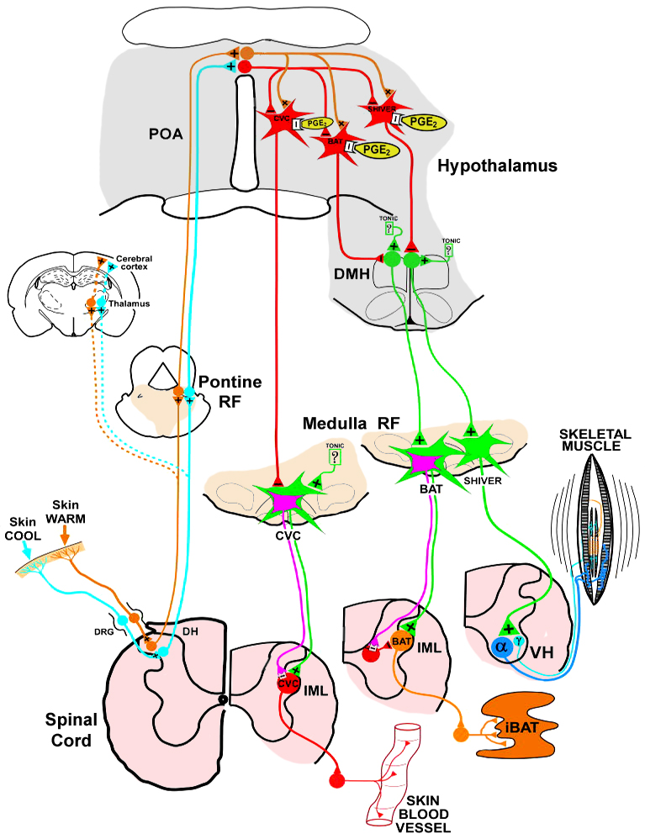
When preoptic warm neurons are activated (Fig. 9, orange), preoptic inhibitory neurons become active and suppress excitation of the the dorso-medial nucleus and the thermoregulatory centers in the RF responsible for the cold responses. This has the dual effect of suppressing the cold responses listed above and allowing the activation of responses that dissipate body heat to the external environment. For example, a second subset of thermoregulatory nuclei in the RF activate sympathetic premotor neurons in the spinal cord to produce skin vasodilation, sweating (humans), panting (animals), salivary spreading (animals) and visceral vasoconstriction. Additional thermoregulatory behaviors may be organized by the hypothalamus, including postural changes, decreased movements, movement to a preferred environment, changing clothes (humans) etc. Again, little is known about the projections mediating these behaviors.
Fig. 9. Temperature control pathways. POA = preoptic area. DMH = dorso-medial hypothalamus. CVC = cardiovascular constriction. BAT = brown adipose tissue. IML = intermediolateral cell column. Adapted from Morrison & Nakamura, Front Biosci. 16: 74-104 (2011).

Reproductive Activity: Reproduction is vital for the survival of the species. In vertebrates, this activity is regulated by the hypothalamus and several nuclei anterior to the hypothalamus in the basal forebrain.
- Subsets of neurons in the preoptic hypothalamus, the septal nuclei and the basal forebrain project their axons into the infundibulum where they secrete gonadotrophin-releasing hormone (GnRH) into the portal circulation (Fig. 7). GnRH is carried via the portal blood into the anterior pituitary where it stimulates the secretion of luteinizing hormone (LH) and follicle-stimulating hormone (FSH) into the general circulation. These hormones stimulate the ovaries and testes to produce and secrete the sex steroid hormones, estrogen and progesterone in females, testosterone in males. In males, FSH and testosterone together stimulate spermatogenesis, while testosterone acts to develop and maintain the male secondary sex characteristics in the genitalia and in other tissues. In females, FSH stimulates follicular development, while FSH and LH together stimulate ovulation and the secretion of estrogen and progesterone. These sex hormones are responsible for the development and maintenance of the female secondary sex characteristics.

- The activity of this brain-pituitary-gonadal axis (system) varies during the life cycle. In the late embryonic and early postnatal periods, there is increased activity to promote some of the development of sexual characteristics of males and females. In addition, exposure to sex hormones during this period alters hypothalamic development. For example, in males, estradiol, produced in the hypothalamus from testosterone, has the effect of enlarging the sexually dimorphic nucleus of the preoptic area (SDN-POA) in rodents and the equivalent in humans, the interstitial nuclei of the anterior hypothalamus (INAH). Perinatal exposure to male sex hormones also stimulates the genesis and survival of additional motor neurons in the motor nucleus of the bulbocavernosus muscle, in the sacral spinal cord, which aids in ejaculatory contractions. In contrast, perinatal exposure to female sex hormones results in a smaller size of these nuclei. Shortly after birth, the system becomes quiescent and resumes activity at the onset of puberty.
Once reproductive function is attained, the system remains active in males for much of the life span. In human females but not in most other species, reproductive function ceases with menopause, which is a loss of ovarian follicles. During the period of reproductive function, the regions of the brain responsible for sexual behavior differ in males and females. Characteristic male sex behavior is driven primarily in the SDN-POA (rodents) or the INAH (humans), while female behavior is organized in the ventromedial nucleus of the tuberal region of the hypothalamus. In addition, the septal area and basal forebrain contribute to the behaviors of both sexes.

Growth: Somatic growth is a process controlled in the hypothalamus.
- Subsets of neurons in the arcuate nucleus in the tuberal region of the hypothalamus project axons into the infundibulum, where they secrete growth hormone releasing hormone (GHRH) into the portal circulation (Fig. 7). Collaterals of these axons project to other arcuate neurons that regulate feeding, so that the supply of nutrients can be regulated together with growth. The portal circulation carries the GHRH to the anterior pituitary where it stimulates the secretion of growth hormone (GH) into the general circulation. GH stimulates growth in virtually every body tissue and organ, and stimulates protein synthesis, lipolysis and carbohydrate metabolism.

- GH stimulates also the liver to produce a second growth hormone, insulin-like growth factor 1 (IGF-1), which is released into the general circulation and has effects similar to those of GH. However, the combination of GH and IGF-1 is much more effective than either one alone. Since IGF-1 is particularly important for the growth and development of the nervous system, it is known as a neurotrophic factor.

Stress: Stress may be defined as an internal or external cue that disrupts homeostatic status. Stress can take the form of hunting, escaping predation, threats to physical integrity or mental, social situations, status, disease, hunger or thirst, cold or heat, pain, etc. Animals, including humans, must adapt to stress in order to survive. The hypothalamus is a key center for organizing the responses to stresses via the hypothalamic-pituitary-adrenal axis (system).
- The paraventricular nucleus in the suprachiasmatic region of the hypothalamus integrates cues representing stress that arrive on several different projections. Cognitive cues from the limbic system are conveyed on axonal projections from the prefrontal cortex, septum, amygdala and hippocampus. Visceral and somatic cues arrive on projections from the brain stem RF, while the circumventricular organs provide information about blood-borne chemosensory signals.

- Activation of one subset of neurons in the paraventricular neurons results in the secretion of ADH into the general circulation from their axonal endings in the posterior pituitary (Fig. 4). Activation of a second subset of paraventricular nucleus neurons results in the release of corticotrophin-releasing hormone (CRH) from their axonal endings into the portal circulation of the infundibulum (Fig. 7). CRH is carried to the anterior pituitary where, together with ADH, it stimulates the secretion of adrenocorticotrophic hormone (ACTH) into the general circulation. ACTH, in turn, stimulates the secretion of glucocorticoid hormones from the cortex of the adrenal glands. The glucocorticoid that is secreted is species dependent; in humans the major steriod is cortisol, while in rodents it is corticosterone. The blood levels of glucocorticoids exhibit a circadian rhythmicity, with levels peaking shortly after waking and falling to a minimum about 15 hr later.

- Corticosteriods are necessary for normal fetal development. Throughout life, glucocorticoids regulate glycogen storage and utilization, elevate heart rate and blood pressure, and cause alterations in blood flow. In general, their role is to mobilize energy stores and improve cardiovascular tone. They also modulate immune responses and inhibit cytokine production, playing a role in the inhibition of inflammatory responses.

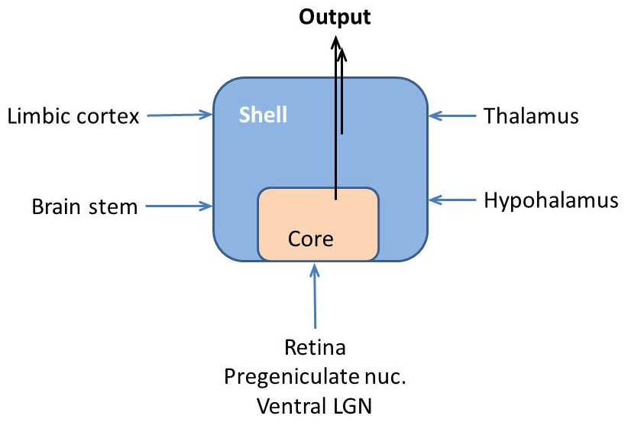
Circadian timing: The function of the circadian timing system is to coordinate a wide series of humoral, physiological and behavioral mechanisms to promote maximally effective sleep and adaptive waking behavior. The circadian system is located in the nervous system and the dominant pacemaker lies in the suprachiasmatic nucleus (SCN) in the supraoptic region of the hypothalamus (Fig.4).
Fig. 10. Suprachiasmatic nucleus input and output.
- The SCN consists of two subsets of neurons arranged into a core and a shell (Fig. 10). Core neurons have an innate circadian fluctuation in their firing rate that has a period of approximately 24 hr. Core neurons receive axons from retinal ganglion cells and from pregeniculate nucleus neurons (primates) or ventral LGN neurons (non-primates) of the thalamus. These axons carry information about the presence and absence of light to entrain the core neurons to environmental day and night. Shell neurons receive axonal projections from the limbic cerebral cortex, the basal forebrain, the brain stem RF, the thalamus, and other areas of the hypothalamus. Inputs from these areas presumably reinforce or perturb circadian timing established by the core neurons.

- Axonal projections emanating from the SCN synapse mainly in other hypothalamic areas. These projections impose a circadian modulation on autonomic functions; the regulation of blood pressure, heart rate, temperature, feeding, metabolism, lactation, hormonal secretions, etc; and the sleep-wake cycle. In addition, the SCN projects axons to the basal forebrain and the thalamus, which impose a circadian modulation on psychomotor performance and memory.

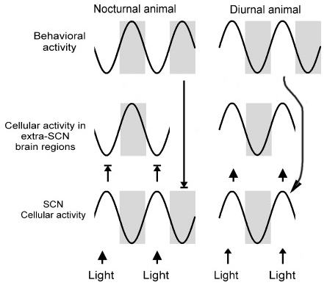
- SCN neurons have a circadian rhythm in their firing rate, with peak rates during the day (light) that are at least twice that of the rates at night. A homeostatic drive for sleep accumulates as a function of the time an individual has been awake. Just after waking, there is little drive for sleep but sleep drive accumulates during waking hours. In diurnal animals (awake and active during the day), just after waking, SCN firing rates are relatively low (Fig. 10). As the day progresses the drive for sleep accumulates and is countered by increased firing rates emanating from the SCN. Thus, SCN firing stimulates arousal and suppresses sleep. At the end of the day, SCN firing rates decline and the unapposed homeostatic drive for sleep induces sleep. After a suitable period of sleep, when the homeostatic drive for sleep has decreased, the firing rate of the SCN, although relatively low, is sufficient to promote arousal. In nocturnal animals (awake and active during the night) SCN firing rates are also stimulated by light but SCN output inhibits brain cellular activity, inhibits behavioral arousal and promotes sleep (Fig. 11).
Fig. 11. Suprachiasmatic nucleus activity and behavior. Modified from Brown and Piggins, Prog in Neurobiol. 82: 229-255 (2007).

Figures

Figs. 1, 3, Box 2. Haines D.E. Neuroanatomy, An Atlas of Structures, Sections and Systems, 7th Edition. Lippincott Williams & Wilkins, Philadelphia PA, 2008.

Fig. 2, 4, 5. Haines D.E. Fundamental Neuroscience for Basic and Clinical Applications, 3rd Edition, Elsevier, Philadelphia PA, 2006.

Fig. 6. Purves D. et al., Neuroscience, 4th Edition, Sinauer, Sunderland MA, 2008.

Fig. 7, 8. Squire, L.R. et al., Fundamental Neuroscience, 2nd Edition, Academic Press, New York NY, 2003.

Additional reading

Haines D.E. Fundamental Neuroscience for Basic and Clinical Applications, 3rd Edition, Elsevier, Philadelphia PA, 2006. Chapter 30, pp. 486-499.

Squire, L.R. et al., Fundamental Neuroscience, 2nd Edition, Academic Press, New York NY, 2003. Chapter 34, pp. 897-909. Chapter 36, pp. 935-944. Chapter 38, pp. 991-1009. Chapter 39, pp. 1011-1029. Chapter 40, pp. 1031-1065. Chapter 41, pp. 1070-1078, 1081-1084.

http://www.endotext.org/neuroendo/neuroendo3b/neuroendo3b_4.htm

