THE UNIVERSITY OF CONNECTICUT
Systems Neuroscience
2012-2013

Gross Anatomy of the Central Nervous System - 1

Lecture
S. J. Potashner, Ph.D.
(sjp9713@neuron.uchc.edu)

Reading
1. Purves et al., Appendix; the relevant material in pp. 717-744
2. This syllabus

A Few Organizational Features of the CNS

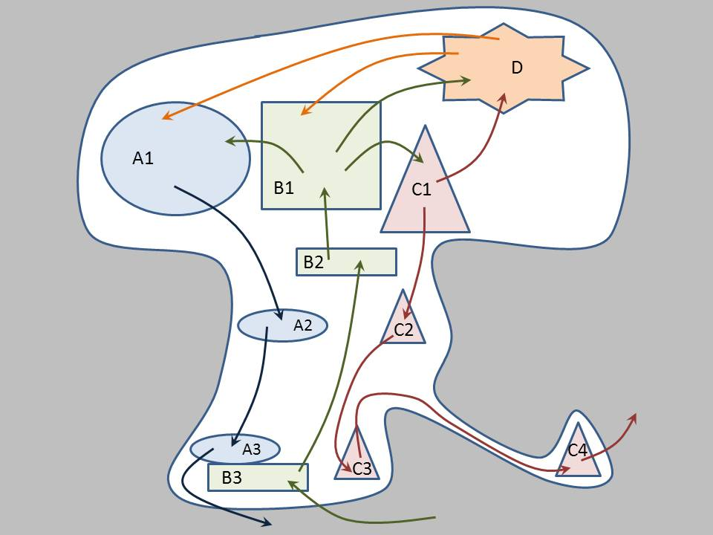
The nervous system has distinct areas that are specialized for different (sub)functions (Fig. 1). As a consequence, we must learn the gross and micro-anatomy of the nervous system and which areas perform the various functions. In addition, since distinct functional areas have different locations inside the nervous system, the functional areas interact by signaling to one another along networks of cells. Thus, we must learn the anatomy of these networks, their cellular composition, and the mechanisms of their signaling. In doing so, we learn that these components are organized into sub-systems (usually called ‘systems’) each of which performs specific functions. For example, the somatosensory systems, which are composed of distinct areas of the nervous system and their connecting networks, provide the capacity to sense touch, temperature, pain, joint position, muscle tension and length; chemical sense systems allow us to taste and smell; special sense systems provide for hearing, vision and balance; motor systems give us the capacity to move, speak, write, express emotions, change our breathing, heart rate and blood pressure; cognitive systems allow us to form perceptions of our environment from sensory information, focus our attention, reason and plan, direct our motor behaviors, synthesize emotions, and exhibit distinct personalities. Finally, consider that pathological lesions can strike anywhere in the nervous system. A lesion may kill areas that are required for specific functions and/or disrupt networks that connect areas. The resulting symptoms can be predicted from a thorough knowledge of the neuroanatomy and neurophysiology of the nervous system.
Fig. 1. Functional areas and systems in the nervous system. The nervous system is represented as the bounded white area. Shapes represent functional areas and arrows indicate network connections. Components of each sub-system have the same shape, color and alphabetic letter.

Lecture Goals

It is logical to begin by learning some of the language of gross anatomy as it is applied to the CNS. This will allow us to describe the various parts of the nervous system, their locations and their relationships to one another using internationally accepted anatomical terms. In subsequent lectures, it will help us to section the CNS in classical anatomical planes and describe the internal structures that we observe.

In this first gross anatomy lecture, we focus mostly on features that are visible on the surface of the CNS, without making sections to explore internal structures.

To learn the gross anatomy relevant to CNS functions, we will identify the major subdivisions of the CNS, as the components of a typical functional system are often distributed in several, if not all, of these subdivisions.

In each subdivision, we will identify characteristic surface features, particularly those that allow us to recognize the subdivision. We will describe the association between the peripheral nerves and the subdivisions from which they enter and/or leave the CNS.

Anatomic Taxonomy
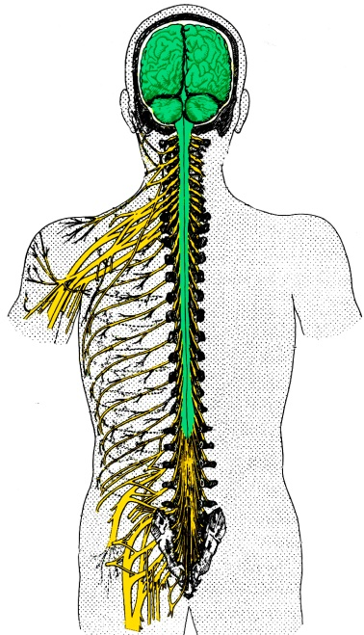
The nervous system functions as one whole organ system, despite the fact that anatomists have used taxonomy to divide it into a hierarchy of the following components:
- The central nervous system (CNS), which consists of the brain and spinal cord (Fig. 2, green; Fig. 3). It is located in and near the midline, and is protected by bones and three outer membranes (meninges). The CNS itself has four main regions (Fig. 3):
- The spinal cord, which can be considered as having cervical, thoracic, lumbar, sacral and coccygeal levels.
- The brain stem, made up of the medulla, pons, midbrain and cerebellum.
- The thalamus
- The forebrain, consisting of the cerebrum and the basal ganglia.
Fig 2. The Central and peripheral nervous systems.
- The peripheral nervous system (PNS) consists of the nerves and nerve cells outside of the CNS. These structures connect the CNS to all parts of the body and to the viscera, and are protected by two outer membranes. Some authors divide the PNS into two functional components:
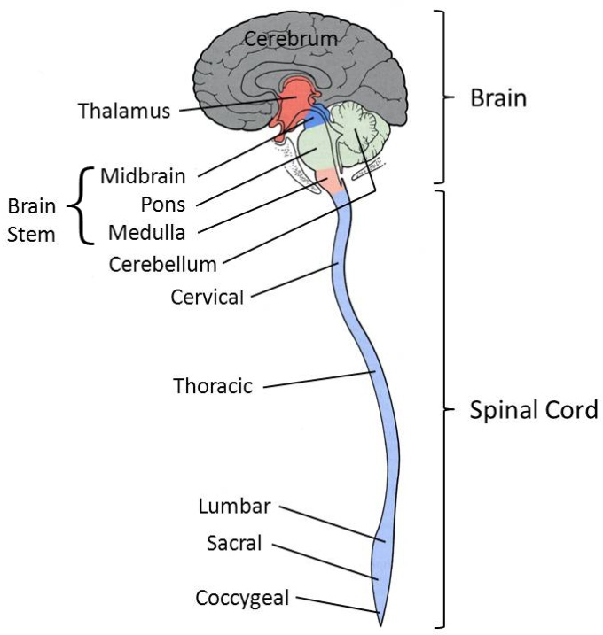
- The somatic PNS, which innervates structures in the body wall (Fig. 2, yellow).
Fig 3. Subdivisions of the CNS.
- The autonomic or visceromotor nervous system (ANS), which innervates smooth muscle, cardiac muscle, and glands.
Anatomical taxonomy is useful, as it provides the names everyone uses for the various regions of the nervous system. It also allows us to localize the functional components of any neural system (eg. the somatosensory system) in individual regions of the nervous system.

Some Anatomical Language

Several imaginary anatomical planes (Fig. 4) form the basis for anatomical descriptions of the locations of structures.

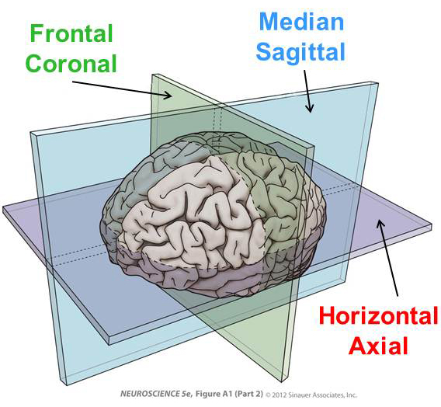
- Median or Sagittal plane: A vertical, front-to-back plane through the midline which divides the body or the CNS into left and right halves. Since the plane corresponds to the location of the sagittal suture of the skull, sagittal became one of its names.
Fig 4. Anatomical Planes
This plane has generated several adjectives, arranged in pairs of opposites, which describe the relationship between structures or compare the locations of two structures. For example, the term ‘medial’ describes a location near the median plane, while ‘lateral’ describes a location more distant from the median plane. Ipsilateral refers to two structures lying on the same side of the median plane, while contralateral refers to two structures on opposite sides of the medial plane.

- Frontal or Coronal plane: A vertical, side-to-side plane that divides the body into anterior (front) and posterior (back) halves. Since the plane corresponds to the coronal suture of the skull, coronal was incorporated as one of its names.
The terms of direction generated by this plane include anterior and rostral, meaning toward the front of the head and the CNS, and posterior and caudal, meaning toward the back of the head and CNS (Fig. 5). The coronal plane can be extended from the head throughout the length of the body. When referring to structures in the body (not the head), the terms anterior and ventral are often used to denote locations toward the front of the body, while posterior and dorsal denote locations towards the back.
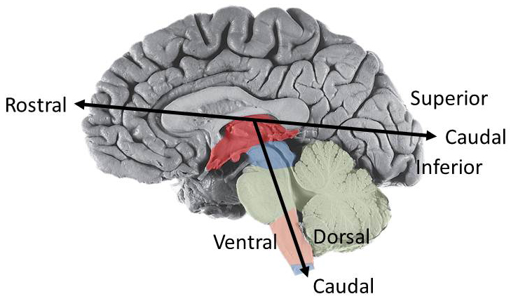
- Horizontal or Axial plane: A horizontal plane, perpendicular to the long axis of the body, which is not fixed in a particular location.
The terms of direction associated with this plane include superior, meaning above the plane, and inferior, meaning a location below the plane. The horizontal plane can be moved below the thalamus, to the level of the brain stem or the spinal cord. In this instance, because of the bend in the axis of the CNS (Fig. 5), the terms rostral and superior become synonymous, as do the terms caudal and inferior.
Fig 5. Axis of the CNS

Subdivisions of the CNS

Most textbooks start with the spinal cord and proceed rostrally to the forebrain. In your wet labs, however, you will probably begin with the brain and study the spinal cord later. This syllabus and the lecture will take the same approach as the lab.

- The brain.
The brain, the part of the CNS located inside the skull, contains several subdivisions.
- The forebrain (telencephalon). The forebrain is easy to recognize, as it is the largest, most convoluted part of the human brain and is located at the top of the brain. The forebrain includes the cerebrum (Figs. 3 & 5) and the basal ganglia (not shown, as it is below the surface). The outer surface of the cerebrum is covered by the cerebral cortex, which is folded into sulci (valleys) and gyri (ridges). The forebrain is divided in the sagittal plane into left and right halves by the longitudinal fissure (Fig. 6).
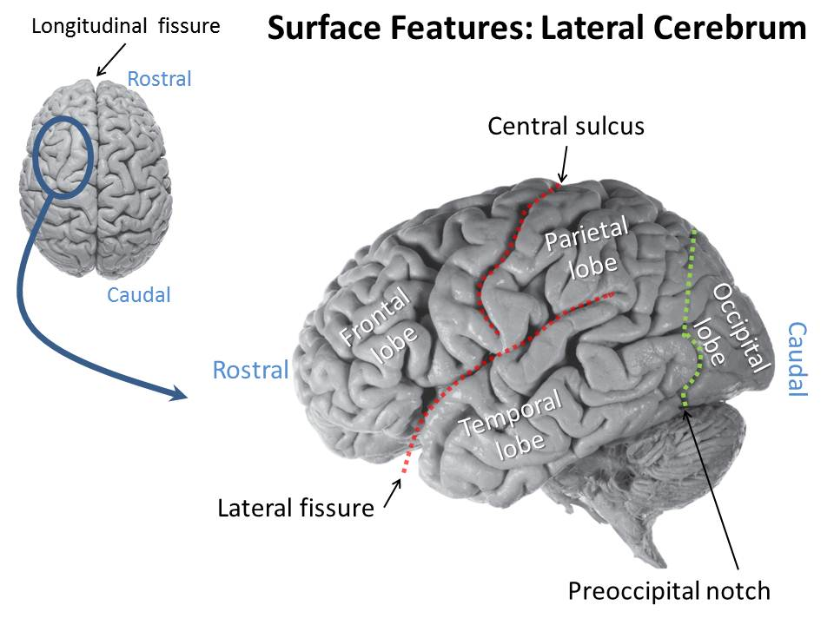
Each side of the forebrain is subdivided into five lobes; four of them are named for the skull bones under which they are located (Fig. 6). On the lateral surface of the cerebrum, the frontal lobe is located rostrally. Its boundaries include the lateral fissure, inferiorly, and the central sulcus, caudally. The parietal lobe, located caudal to the frontal lobe, has boundaries that include the central sulcus, rostrally, the lateral fissure, inferiorly, and an imaginary line extending from the preoccipital notch, inferiorly, to the parieto-occipital sulcus, superiorly (Fig. 6, green). The temporal lobe lies inferior to both the frontal and parietal lobes. Its boundaries include the lateral fissure, superiorly, and the previously described imaginary line, caudally. The occipital lobe, at the caudal extent of the cerebrum, is bounded rostrally by the previously described imaginary line. The fifth lobe, the insula, is located deep inside the lateral fissure and can be observed by pulling the temporal lobe laterally.
Fig 6. Lobes of the cerebrum viewed laterally.
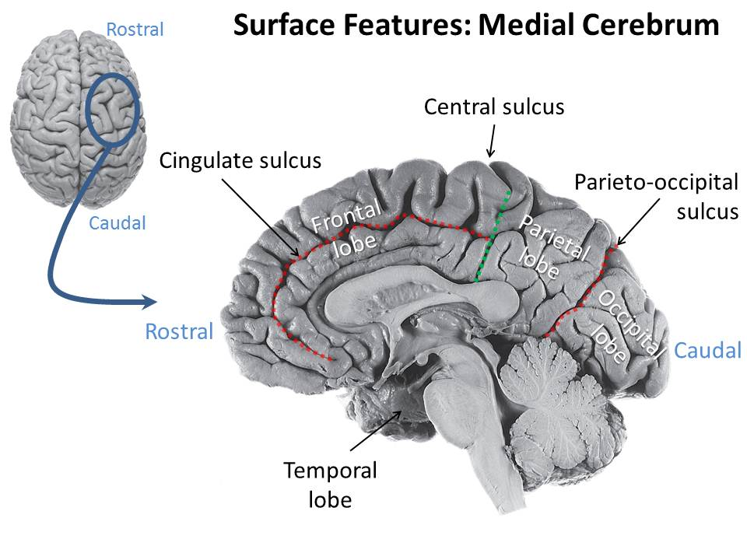
The frontal, parietal and occipital lobes extend onto the medial surface of the cerebrum, which lies in the walls of the longitudinal fissure (Fig. 7). On this medial surface, the frontal lobe is bounded caudally by an imaginary line drawn from the central sulcus, superiorly, to the caudal end of the thalamus, inferiorly (Fig. 7, green). This same line forms the rostral boundary of the parietal lobe, which extends caudally to the parieto-occipital sulcus. This sulcus marks the rostral boundary of the occipital lobe.
Fig 7. Lobes of the cerebrum viewed medially
The only nerve associated with the forebrain is cranial nerve I, the olfactory nerve, which enters the olfactory bulb from the nasal mucosa (Fig 8). The olfactory bulb communicates sensations of smell to structures in the infero-rostral forebrain via the olfactory tract.

- The thalamus (diencephalon). The thalamus is not easily seen, as it is located between the forebrain and the brain stem and almost completely surrounded by the forebrain superiorly and laterally (Fig. 8, red). One part of it can be recognized on the inferior surface of the brain, caudal to the optic chiasm, as it contains the mammillary bodies. Also, its midline features can be observed when the brain is cut in half in the sagittal plane.
Considering what can be observed in the midline view after the sagittal cut, the thalamus consists of the dorsal thalamus (usually just called the ‘thalamus’) and the hypothalamus. The (dorsal) thalamus consists of two egg-shaped structures, one associated with each cerebral hemisphere, separated by the slit-like third ventricle in the midline, a space that is filled with cerebro-spinal fluid (CSF). The hypothalamus is inferior to the rostral half of the (dorsal) thalamus, and comprises the tissue in the lateral and inferior walls of the inferior part of the third ventricle.
The only nerve associated with the thalamus is cranial nerve II, the optic nerve (Figs. 8-9), which conveys visual signals from the retina in the eye to the thalamus and the hypothalamus.

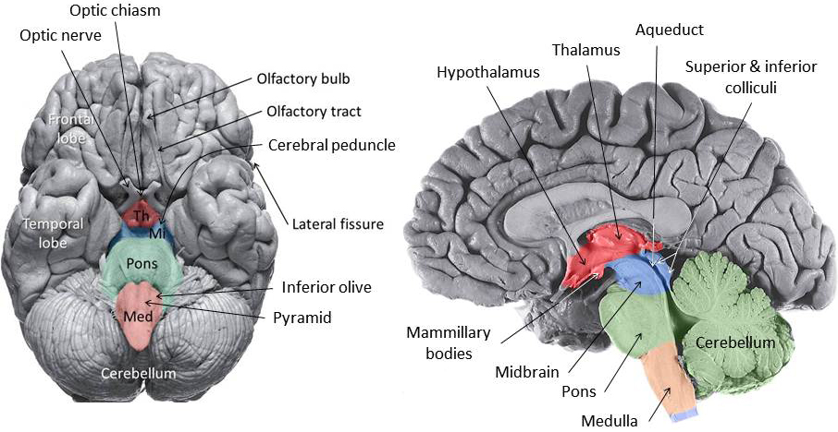
Fig 8. The brain Stem.

- The brain stem. The brain stem is a cylindrical structure located caudal to the thalamus and rostral to the spinal cord. It consists of three parts.
- The midbrain (mesencephalon) is the most rostral part of the brain stem Fig. 8, blue). It is also not easily seen, as it is located caudal to the thalamus and rostral to the pons, and is surrounded laterally and dorsally by the cerebrum. The ventral surface of the midbrain, which contains the cerebral peduncles, can be recognized on the ventral surface of the brain stem rostral to the pons and lateral to the mammillary bodies. The dorsal surface of the midbrain, containing the superior and inferior colliculi, can be observed on the dorsal side of the brain stem when one separates the occipital part of the cerebrum from the adjacent cerebellum.
When the brain stem is cut in half in the sagittal plane, each of the left and right halves of the midbrain can be seen to be divided into two parts by the aqueduct, a small longitudinal tube, lying in the midline and connecting the third and fourth ventricles. These two parts consist of a dorsal tectum (roof), containing the superior and inferior colliculi, and a ventral tegmentum (basement), containing the cerebral peduncle.
Two crainial nerves are associated with the midbrain (Fig. 9). Crainial nerve III, the oculomotor nerve, emerges from the ventral surface of the midbrain, medial to the cerebral peduncle. Cranial verve IV, the trochlear nerve, emerges from the posterior surface, just caudal to the inferior colliculus. Both nerves course rostrally to enter the orbit and carry motor signals to extraocular muscles that move the eyes. The oculomotor nerve also innervates intrinsic eye muscles that control pupillary constriction and the upper eye-lid opener muscle.

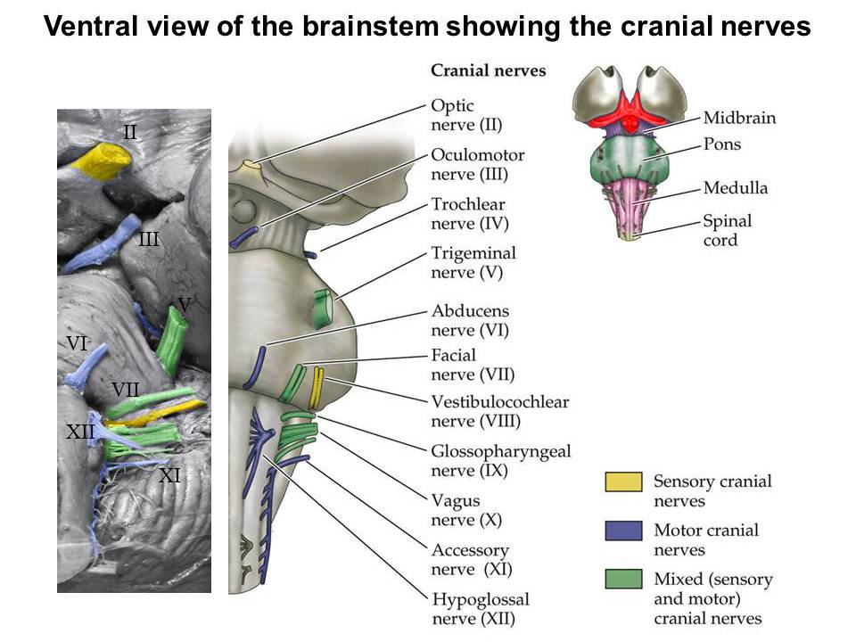
Fig 9. the cranial nerves

- The pons (metencephalon) is the middle portion of the brain stem. It is located caudal to the midbrain and rostral to the medulla (Fig. 8, green). It is an easily recognized part of the brain stem as it bulges into a large dome, ventrally, and is connected to the cerebellum dorsally. The ventral dome is often called the ‘pontine protuberance’.
When the brain stem is cut in half in the sagittal plane, both the ventral dome and the cerebellum remain as obvious features of the pons. In addition, the pons is separated from the cerebellum by the rostral half of the fourth ventricle.
The cerebellum, meaning ‘little brain’, is located dorsal to the brain stem. It is usually associated with the pons because the largest connection between the brain stem and the cerebellum lies in the pons. Actually, the cerebellum also has more modest connections to the midbrain, the medulla and the spinal cord, but these are not easily seen as surface features. The cerebellum is covered with a cortex which is folded horizontally into ridges called ‘folia’ (leaves).
Only cranial nerve V, the trigeminal nerve, is associated with the rostral part of the pons (Fig. 9). It emanates laterally. It carries sensations from the head into the brain stem and motor signals from the pons to the muscles of mastication.

- The ponto-medullary junction, although not a subdivision of the brain stem, is noteworthy because three cranial nerves are associated with it. It is located at the caudal border of the pons and the rostral border of the medulla (Fig. 9). Cranial nerve VI, the abducens nerve, emanates medially from this border to course rostrally and enter the orbit to innervate one extraocular eye muscle. Cranial nerve VIII, the vestibulo-cochlear nerve, emanates from the lateral extent of this border and courses into the temporal bone to innervate the inner ear. The vestibular part of the nerve conveys signals from the labyrinthine organs of the inner ear to the brain stem. The cochlear part of the nerve conveys signals from the cochlea of the inner ear to the brain stem. Just medial to cranial nerve VIII, cranial nerve VII, the facial nerve, emanates from this border. It courses laterally passing the rostral border of the ear, then turns rostrally to innervate and carry motor signals to the muscles of facial expression as well as salivary, tear and nasal glands. A branch of the nerve also courses into the tongue and carries sensations of taste from the tongue to the brain stem.

- The medulla (myelencephalon). The medulla is the most caudal part of the brain stem, extending from the spinal cord, caudally, to the pons, rostrally (Fig. 8, pink). It is roughly cylindrical in shape but several surface features make it easy to recognize. Ventrally, there is an anterior median fissure and two long cylindrical ridges on either side of the midline, which form the ‘pyramids’. Just lateral to the rostral half of the pyramids, two more rounded bulges appear and form the ‘inferior olives’. The dorsal surface of the medulla is largely covered by the cerebellum.
When the brain stem is cut in half in the sagittal plane, it becomes apparent that the dorsal surface of the medulla is associated with the fourth ventricle and the cerebellum. However, it is only to the rostral half of the medulla that borders on the caudal part of the fourth ventricle. The remaining caudal half of the medulla is mostly covered by the cerebellum.
Four cranial nerves are associated with the medulla (Fig. 9). Cranial nerve XII, the hypoglossal nerve, emerges between the pyramid and the inferior olive and carries motor signals to muscles of the tongue. The remaining nerves emerge from the lateral surface of the medulla. The most rostral, cranial nerve IX, the glossopharyngeal nerve, emerges just below the border with the pons. It carries motor signals to muscles in the palate and pharynx, and to the parotid salivary gland. Branches carry signals of taste from the throat and posterior tongue, and signals representing oxygen and carbon dioxide levels in the blood from the carotid body, into the brain stem. Cranial nerve X, the vagus, emerges caudal to the glossopharyngeal nerve. It carries motor signals to muscles in the pharynx, larynx and upper esophagus, and to the heart and most of the gut. It carries sensory signals from the pharynx, tongue, thoracic and abdominal organs into the brain stem, taste signals from the posterior tongue and throat into the medulla and signals representing blood pressure from the heart and great blood vessels into the medulla. Crainial nerve XI, the accessory nerve, emerges laterally from the caudal medulla and courses rostrally to accompany the vagus nerve. The accessory nerve carries motor signals to two muscles of the neck and shoulder.

- The spinal cord. A long cylindrical structure of modest diameter that extends caudally from the medulla into the vertebral canal of the vertebral column (Fig. 2). It is easy to recognize because it is a slim structure that is between one and two feet in length. Although there are few surface features, perhaps the most prominent is the anterior (ventral) median fissure (Fig. 11), which divides the cord into left and right halves and is usually occupied by the anterior spinal artery.
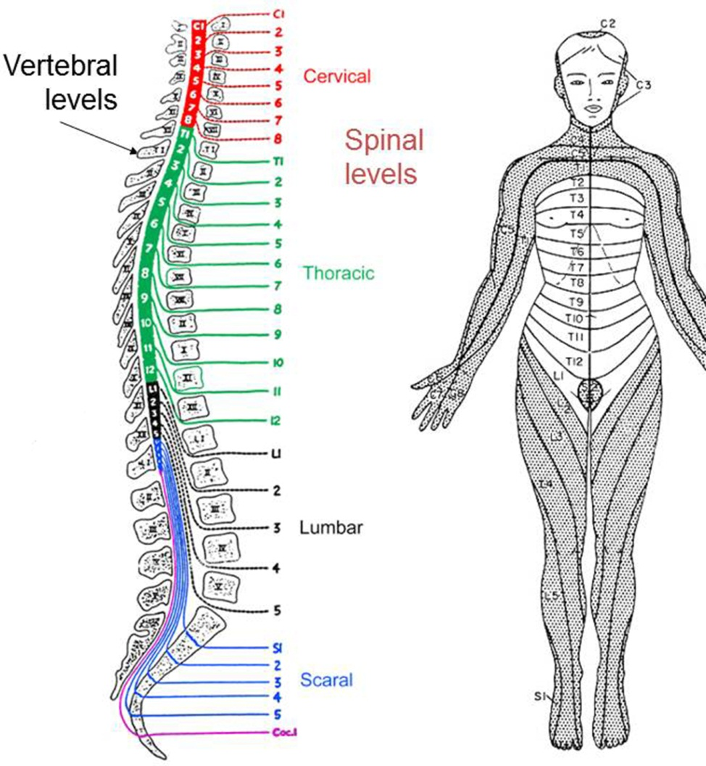
There are 31 pairs of spinal nerves that connect the spinal cord to the body (Fig. 10). Each nerve emerges from the spinal cord to pass between two adjacent vertebrae to reach the periphery. The location of this passage gives the name to the nerve and to the level of the cord from which it came. For example, there are 7 cervical vertebrae. Cervical nerve 1 (abbreviated C1), which comes from the 1st spinal cervical level (also abbreviated C1), exits to the periphery by passing rostral to the C1 vertebra. The C2 nerve exits by passing rostral to the C2 vertebra, etc. However, there is a C8 level of the spinal cord and its nerve (C8) exits to the periphery by passing caudal to the C7 vertebra. This establishes a new precedent, so that all caudally subsequent nerves exit by passing caudal to the vertebra of the same name. For example, the 1st thoracic (T1) and 2nd lumbar (L2) nerves exit caudal to the T1 and L2 vertebrae, respectively. There are 8 pairs of cervical spinal nerves and spinal segments, 12 thoracic, 5 lumbar, 5 sacral, and 1 coccygeal.
Fig 10 Spinal levels, nerve roots and dermatomes
The adult spinal cord ends between vertebra L1 & L2, forming a tapered point called the ‘conus medullaris’. The covering pial membrane thickens into a ligament, the ‘filum terminale’, which anchors the conus to the coccygeal bones. The mismatch in length arises during maturation, when the vertebral column elongates more extensively than the spinal cord. Another consequence of this discrepancy is that nerve roots emerging from the spinal cord must elongate within the vertebral canal to reach their exit points between the vertebrae. The resulting array of hanging nerve roots is called the ‘cauda equina’ (horse’s tail).

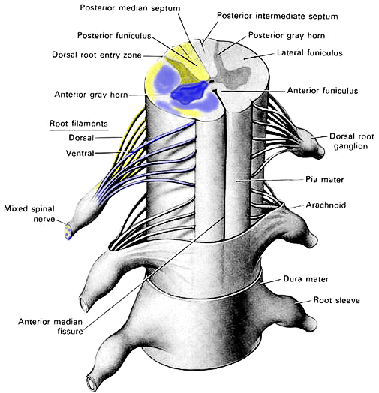
Nerve roots emerge from the spinal cord along its entire length (Fig. 11). One set, called the ‘ventral roots’, emerge from the ventro-lateral surface and carry motor fibers into the spinal nerves, which carry motor signals to muscles and glands in the periphery. Another set, called the ‘dorsal roots’, emerge on the dorso-lateral surface of the cord and they carry sensory signals from the periphery through the spinal nerve into the spinal cord. Several adjacent dorsal and ventral roots course together to enter a single spinal nerve. The region of the spinal cord contributing these roots is named for the spinal nerve that receives them. A swelling in the dorsal root contains the cell bodies of the sensory neurons in the root and the nerve. This collection of cell bodies is called the ‘dorsal root ganglion’ (DRG). A ‘ganglion’ is the name given to a collection of nerve cell bodies that lie outside the CNS. The cell bodies of the motor fibers are inside the spinal cord.
Fig 11. Structure of the spinal cord and the spinal nerve roots
The arrangement of the vertebrae and the spinal nerves reflect a segmental organization in the body that was constructed during fetal development. At that time, specific regions of the spinal cord were connected by nerve fibers to specific territories (somites) in the periphery. This arrangement persists in the adult and is reflected most dramatically in the sensory innervation of the skin. The skin surface can be divided into ‘dermatomes’ (Fig. 10); each one is innervated by the sensory fibers in a specific spinal nerve root which emerges from a specific level of the spinal cord. The dermatomes are named according to the spinal nerve root that innervates them.

Web Resources

Mouse brain atlas
Allen Inst. mouse brain atlas http://mouse.brain-map.org/static/atlas
Harvard mouse brain atlas http://www.hms.harvard.edu/research/brain/atlas.html
Laboratory of Neural Imaging http://www.loni.ucla.edu/Atlases/index.jsp

Human brain atlas
Allen Inst. human brain atlas http://human.brain-map.org/mri_viewers/data
Harvard human brain atlas http://www.med.harvard.edu/AANLIB/home.html
Laboratory of Neural Imaging http://www.loni.ucla.edu/Atlases/index.jsp

The Rat Brain
From The University Of Western Ontario, London, Canada
Anatomy 9535b. Anatomical Foundations of Neuroscience.
http://instruct.uwo.ca/anatomy/530/ratpix.pdf

