Graduate School Systems neuroscience, MEDS 5371
2013

THE SPINAL CORD

1. READING
Purves et al.4th Ed.: parts of Chs. 9,10,16 ; Figs. 9.8, 9.9, 10.3, 16.13, 16.14

INTRODUCTION

Spinal cord (SC), a part of the CNS, is 40-50 cm long, located in the vertebral canal, and is connected to the periphery by 31 pairs of spinal nerves.

31 pairs of spinal nerves are divided by their position into 8 cervical; 12 thoracic; 5 lumbar; 5 sacral; 1 coccygeal pair.

The segmental pattern of the spinal nerves is maintained in the periphery. Dermatomes are areas on the skin that is supplied by sensory fibers from a single spinal nerve.

Spinal cord ends between vertebrae L1 & L2 with conus medullaris and filum terminale, which is connected to the coccygeal bone. Cauda equina refers to the spinal roots below the spinal cord.

There are two enlargements of the spinal cord:

cervical at the level of C5-C8 and lumbo-sacral at L3-S3. These levels serve the arms and legs respectively and have more motor neurons and contain more axons in the white matter.

The Spinal cord receives sensory information from receptors in the periphery which are attached to primary sensory neurons located in the dorsal root ganglion (DRG). The distal process of neurons in the DRG is sent to the periphery and the proximal process enters the spinal cord through the dorsal root.

Cross section of THE SPINAL CORD

In the cross section of the SC, the grey matter (cell bodies) is located inside, with white matter (myelinated axons) positioned outside and covered with meninges.

White matter:

In the cross section, the white matter is divided into dorsal, ventral, and lateral columns (funiculi) that contain long axons belonging to various pathways.

Dorsal column (funiculus) conducts sensory information representing light touch, vibration, two point discrimination and proprioception (musle length, tendon tension, joint position) to upper levels (the medulla). It is divided into Fasciculus gracilis medially (bring information from legs) and fasciculus cuneatus laterally (sensory information from arms). Other fibers coming through dorsal root carry pain, temperature and crude touch sensations (see below).

Lateral funiculus contains both descending and ascending tracts. The largest one is descending lateral cortico-spinal (pyramidal) tract that carries information from the motor cerebral cortex to α-motor neurons in the ventral horn of the spinal cord. Ventral to it is the rubro-spinal tract with similar functions but originating in the red nucleus.
On the lateral side of the SC there are two tracts that connect the spinal cord with cerebellum: the ventral and dorsal spinocerebellar tracts (see below).

Anterior funiculus contains motor tracts: the anterior cortico-spinal, reticulo-spinal and vestibulo-spinal tracts.

The gray matter

The gray matter of the spinal cord is positioned in the middle and consists of cell bodies. It has a butterfly shape which varies in size from level to level. It is divided in dorsal and ventral horns. The gray matter on each side is connected by the gray commissure, which surrounds the central canal, which is obliterated in adults.

The dorsal horn
Dorsal horn is divided into several laminae. The most dorsal is the marginal zone (lamina I), followed by the substantia gelatinosa (lamina II), and nucleus proprius (laminea IV,V). At the base of dorsal horn at segments T1-L2 is Clark’s nucleus from where dorsal spinocerebellar tract originates.

The Ventral horn contains large alpha-motor neurons that send their axons through spinal nerve to innervate skeletal muscles. They are surrounded by interneurons and γ- motor neurons which contact muscle spindles (intrafusal fibers-see below). Motor neurons are organized into nuclei - each innervates a single muscle. Motor neuron nuclei representing distal muscles of legs and arms are positioned laterally in the ventral horn, whereas those representing proximal muscles are located medially.
Neurons that innervate extensor muscles are represented superficially in the ventral horn by cell groups along its outer edge, while neurons for flexor muscles are positioned deeper in the ventral horn.

The intermedio-lateral column

This column is present at levels T1-L2- It is the sympathetic autonomic nucleus and is located at the lateral border of the intermediate gray matter (Purves, Fig. 21.2, p. 519). The cells in this nucleus are preganglionic, sympathetic neurons (Purves, Chapter 21). They send their myelinated axons out of the spinal cord via the ventral roots and they project into the sympathetic ganglia which form a chain on the lateral side of the vertebrae. Ganglion cells in these ganglia project their axons back into the spinal nerves to innervate smooth muscle and glands at the periphery (Purves, Fig. 21.2).

At sacral levels S2-S4- the intermediolateral cell column contains the preganglionic, parasympathetic neurons (Purves, Fig. 21.1).

Neural pathways in the spinal cord

1. Primary sensory neurons

1a. Primary sensory neurons:

Cell bodies of primary sensory neurons are in the dorsal root ganglion (DRG). The distal end of its peripheral axon is associated with a sensory receptor (eg. touch receptor in skin; joint position receptor). Its central axon projects through the dorsal root to enter the spinal cord in the dorsal column, medial to the dorsal horn. Here it bifurcates into an ascending and a descending branch that carry information about crude touch, two point discrimination and vibration. The dorsal column consists of fasciculus gracilis (legs) medially and fasciculus cuneatus (arms) laterally. These fibers end in the medulla, in N.gracilis and N.Cuneatus. Second order neurons send axons that cross, and continue close to midline as the Medial Lemniscus (ML). Note that at this point information from one side of the body is carried by the ML on the opposite side (crossed). The ML brings sensory information to the thalamus ending up in the ventro-posterior lateral nucleus (VPL). Third order neurons send information further up into the somatosensory cortex (postcentral gyrus).

1b) Pain and temperature- The fibers with the smallest diamaters (group IV & C), convey information about pain and temperature, and are unmyelinated. They enter the dorsal column most laterally of all the primary afferents and form a pale band on top of the marginal zone of a dorsal horn. This part of the dorsal column is called Lissauer's tract . The collaterals of these branches synapse in the two uppermost layers of the dorsal horn, the marginal zone and the substantia gelatinosa, or a little below in N. proprius. Second order axons start in the N.Proprius, cross the midline and position themselves between the lateral and ventral (or anterior) funiculus as the ascending spino-thalamic tracts, also known as antero-lateral system (ALS) or spinal lemniscus. This tract carries pain sensation to the thalamus (VPL-ventro-posterior lateral nucleus) and further to somato-sensory cortex. Other destinations of this tract are related to psychological aspect of pain- anguish. These connections end up in the reticular formation, amygdale, periaqueductal gray, hipothalamus or midline thalamus. From this last destination projections carrying pain sensation reach insular and cingulated cortex.

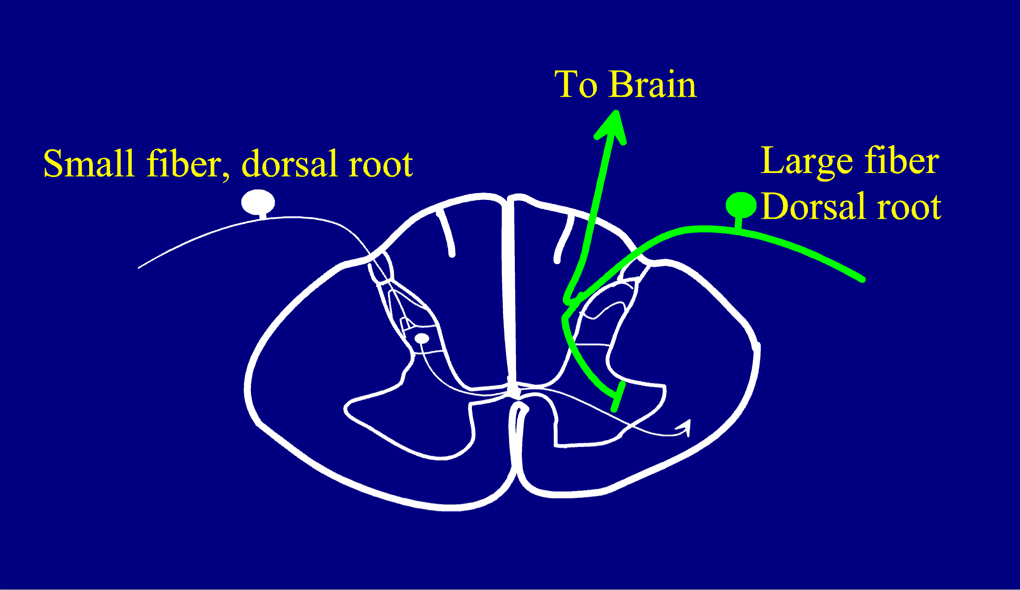

N.Proprius
Proprioception: sensations generated by movements that help in monitoring and, if necessary, correcting the movements.

Dorsal spino-cerebellar tract originates in the Clarke’s nucleus in the dorsal horn at levels T1-L2 and supplies information from the spinal cord to the cerebellum. This nucleus receives collaterals of Ia & Ib primary afferents from muscle spindles, tendon organs and joint receptors in the trunk and the lower extremity. Neurons in Clarke's nucleus send their axons into the lateral column of the spinal cord on the same side as the dorsal spino-cerebellar tract. This uncrossed tract supplies the cerebellum with proprioceptive information about muscle length, and joint position in the trunk and the lower limb from the same side of the body.

Ventral spino-cerebellar tract is different from the dorsal one, since it conveys copies of motor activity from the ventral horn to the cerebellum. Axons from motor cortex end on interneurons in the ventral horn, which project to opposite lateral column and become ventral spino-cerebellar tract, positioned immediately ventral to the dorsal spino-cerebellar tract.

Ascending (sensory) pathways in the spinal cord:
Dorsal column (fasciculus gracilis and f.cuneatus)
ALS- or spino-thalamic tr.
Dorsal and ventral spino-cerebellar tr.

Descending (motor) pathways:
Corticospinal lateral and anterior tr.
Vestibulo-spinal
Rubro-spinal
Tecto-spinal
Reticulo-spinal
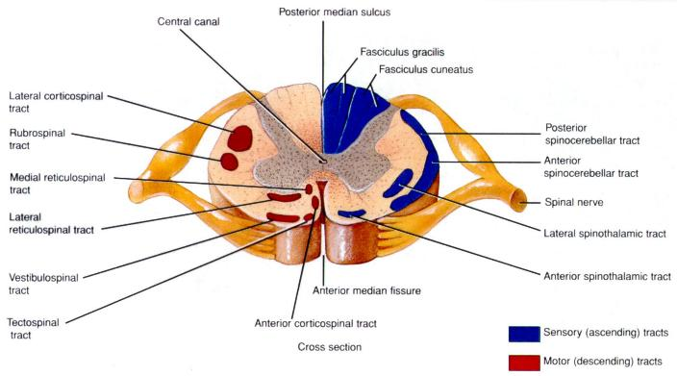
Upper motor neuron-(UMN) refers to neurons in the cerebral cortex that project through the cortico-spinal and other tracts and control the activation of lower motor neurons. Lesion of these neurons or tracts results in spastic paralysis, hypertonia, hyper-reflexia, pathological reflexes (Babinski).
Lower motor neuron (LMN) refers to a-motor neurons in the ventral horn of spinal cord that synapse on skeletal muscles. Lesion of LMN produces flaccid paralysis, areflexia, hypotonia and muscle atrophy.

