THE UNIVERSITY OF CONNECTICUT
Systems Neuroscience
2012-2013

Anatomy of the Cerebrum (Telencephalon)

S. J. Potashner, Ph.D.
(sjp9713@neuron.uchc.edu)
Lecture

READING
1. Purves, Appendix, pp. 728-735; Chapter 26, pp. 587-590.
2. This syllabus

ANATOMY

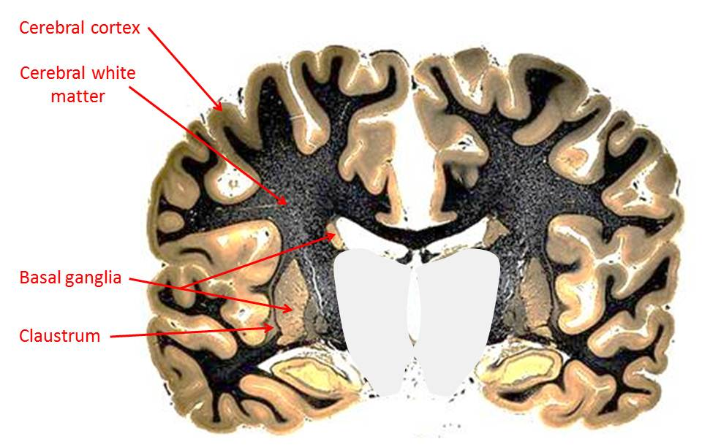
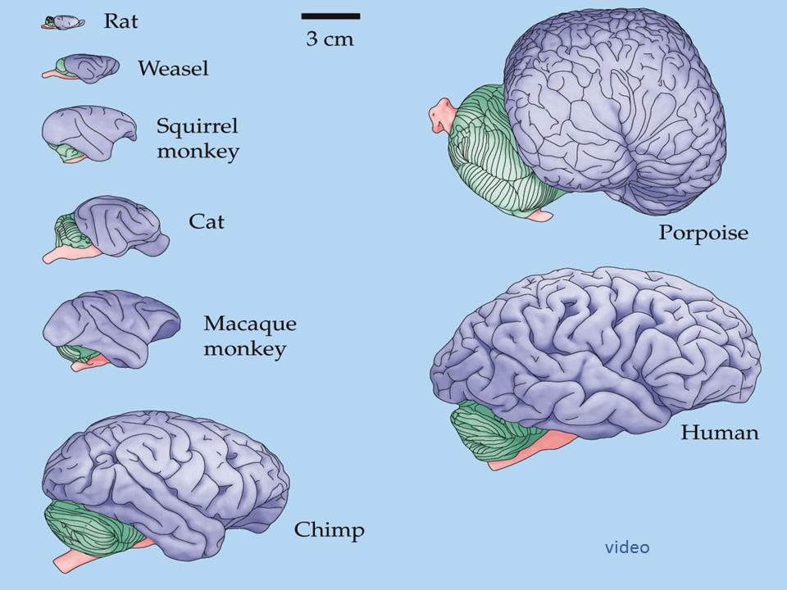
The brain consists of the brain stem (the medulla, pons and midbrain), the thalamus (the dorsal thalamus, hypothalamus and epi-thalamus) and the cerebrum. The cerebrum, which is concerned mainly with cognition, can be divided into the cerebral cortex, the cerebral white matter and the subcortical nuclei (Fig. 1).
Fig. 1. The cerebrum (telencephalon) in coronal section.
Fig. 2. Brain sizes.

Brain size has increased during evolution, and its complexity and size has culminated in humans (Fig. 2). The capacity of the human brain to support complex signal processing has allowed humans to develop intricate social interactions, societies, motor skills and cognitive activities. A major factor in this development is the surface layer of cerebral cortex; in humans, it is highly folded to increase its size, and the number of cells and cellular connections that it contains.

The Cerebral Cortex – Gross Anatomy

The cerebrum is divided into left and right hemispheres by the longitudinal fissure (Figs. 1 & 3). In each hemisphere, the cortical folds create elevations, called gyri (gyrus = singular), and fissures, called sulci (sulcus = singular). The sulci are deep enough to include a substantial portion of the underlying cortical white matter.

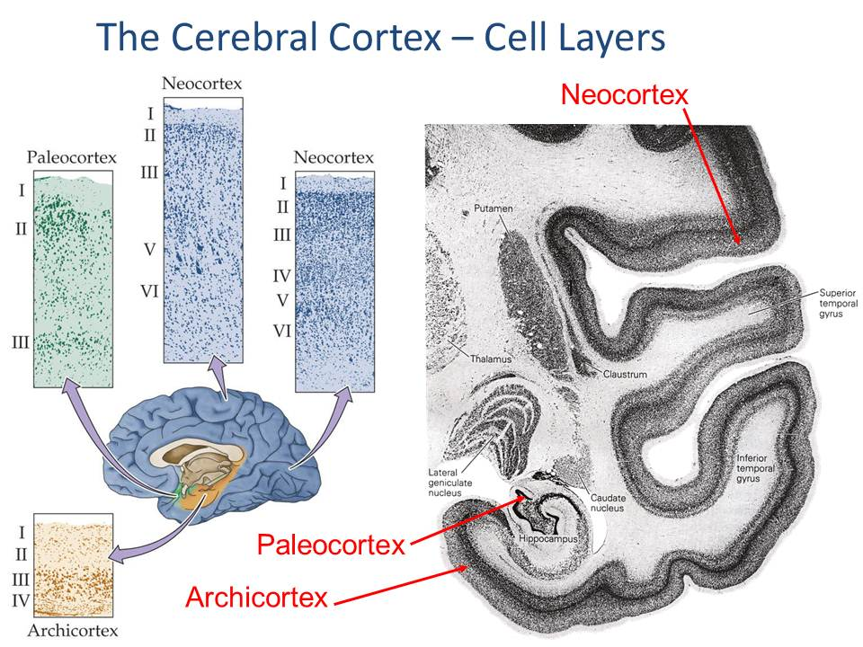
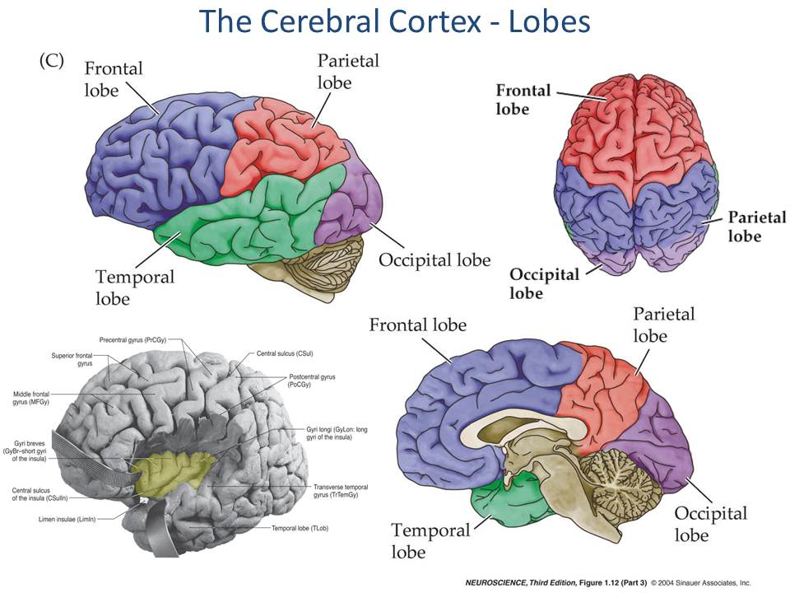
The arrangement of the major sulci divides the cerebral cortex of each hemisphere into five lobes (Fig. 3). On the lateral surface of the hemisphere, the lateral sulcus (fissure), the superior end of the parieto-occipital sulcus, and the central sulcus form the boundaries of the frontal, parietal and temporal lobes. An imaginary line connecting the superior end of the parieto-occipital sulcus and the parieto-occipital notch forms the rostral border of the occipital lobe. The insular lobe lies deep within the lateral fissure. Extensions of these lobes are apparent on the medial surfaced of the hemispheres, on the walls of the longitudinal fissure. Some authors identify a sixth lobe, called the limbic lobe. It consists of a belt (limbus) of tissue surrounding the corpus callosum and includes the cingulate gyrus and the septal area of the medial frontal lobe, and the parahippocampal area of the medial temporal lobe.
Fig. 4. Cell layers of the cerebral cortex.
Fig. 3. Lobes of the cerebral cortex.

The Cerebral Cortex – Cell Layers

All of the cerebral cortex is organized into layers of cells that are parallel to the pial surface (Fig. 4). Most of the cortex has six layers of cells and is named neocortex. However, near the medial surface of the temporal lobe, the layering of the cortex changes. The six layers of the inferior temporal area gradually reduce to four cell layers as we approach the medial surface of the temporal cortex. This type of cortex, with less than six layers, is known as archicortex. Moving from the medial surface of the temporal lobe to the hippocampal formation, we encounter the three-layered cortex of the hippocampus, known as paleocortex.

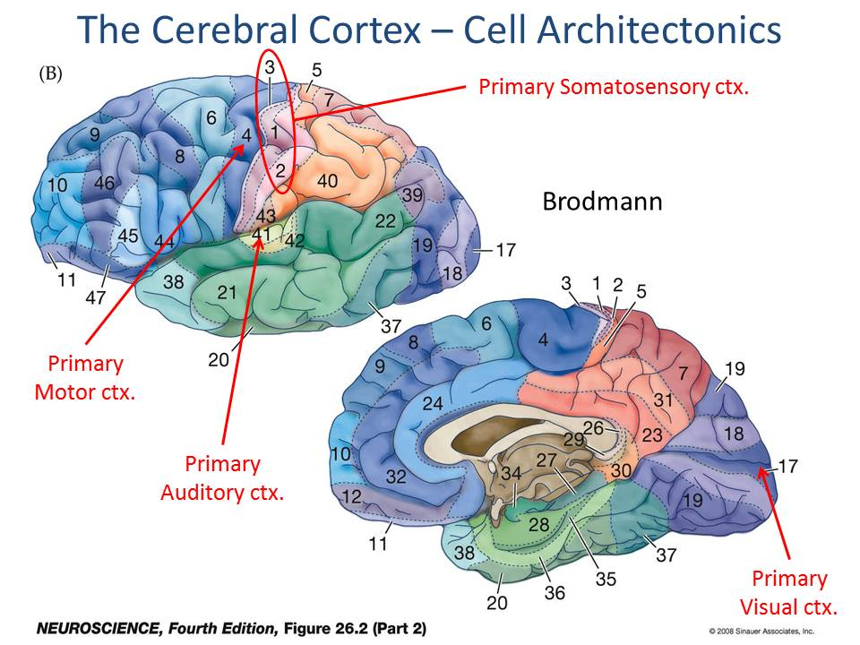
The Cerebral Cortex – Cell Architectonics
Fig. 5. Cortical cytoarchitectonics.

Despite the presence of six cell layers throughout much of the cortex, differences were discovered in layer size and the size, number, density and distribution of neurons within the layers in subregions of the cortical mantle. Based on such cytoarchitectonic differences, Brodmann distinguished approximately 50 different areas of the cerebral mantle (Fig. 5). Although Brodmann did not study the functional significance of these areas, subsequent research has revealed many of the functions associated with individual cortical areas. Many of the areas distinguished by Brodmann have been found to have distinct functions.
The Cerebral Cortex – Functional Columns

In a recent review, Vernon Mountcastle, one of the first to describe the vertical columnar organization of the cerebral cortex, wrote …

“The basic unit of cortical operation is the minicolumn… It contains of the order of 80-100 neurons, except in the primate striate cortex, where the number is more than doubled. The minicolumn measures of the order of 40-50 um in transverse diameter, separated from adjacent minicolumns by vertical, cell-sparse zones… Cortical columns are formed by the binding together of many minicolumns by common input and short-range horizontal connections. The number of minicolumns per column varies… between 50 and 80. Columns vary between 300 and 500 um in transverse diameter.”
Mountcastle, VB. Cerebral Cortex, 13: 2-3 (2003).

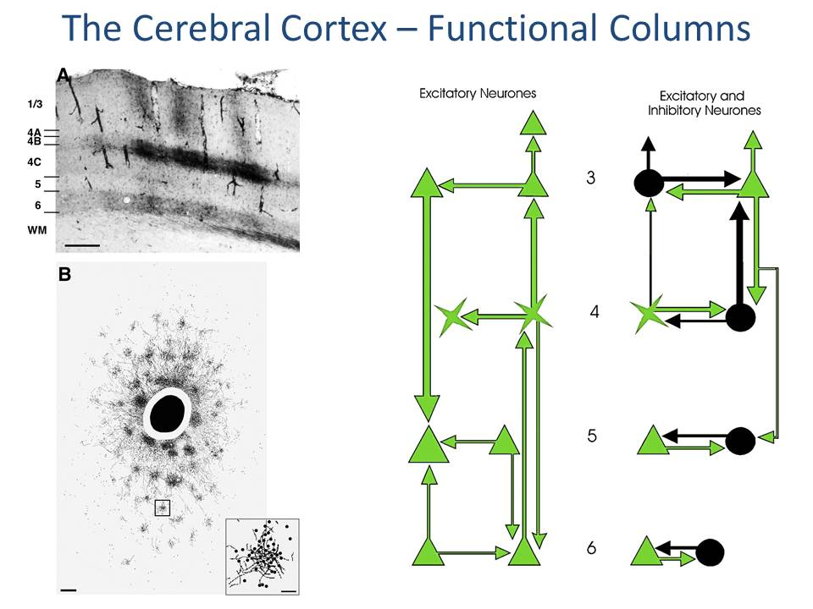
Research has demonstrated the presence of minicolumns and that the neurons in them have many more synaptic connections within the minicolumn than with neighboring minicolumns (Fig. 6). Connections between neighboring minicolumns are most abundant in layers 2, 3 and 4. Through these connections, columns can be bound together into modules and areas that support complex physiological functions, such as ocular dominance; visual sensitivity to movement; motor control over grasping, reaching and defensive movements. (Fig. 7)
Fig. 6. Cortical minicolumns

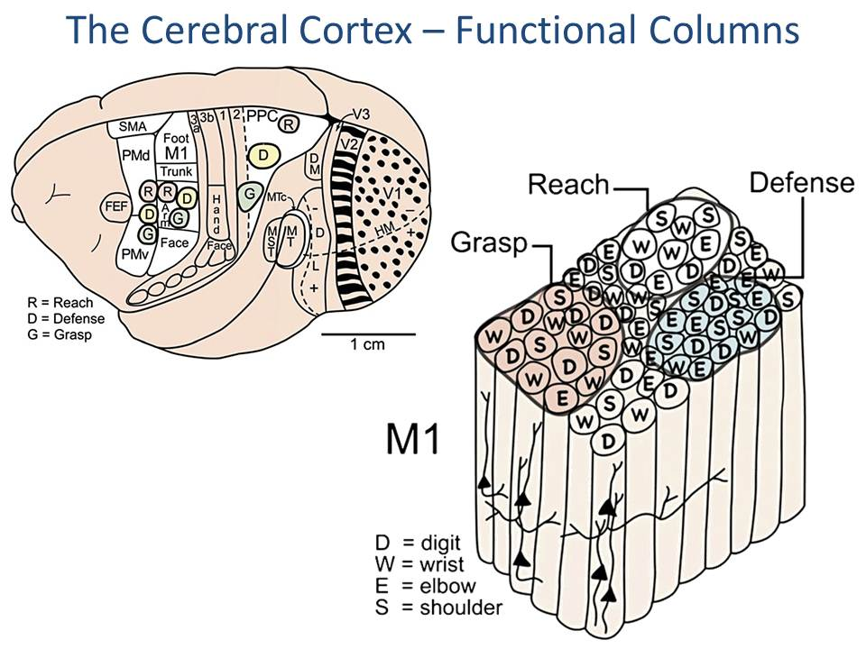
The Cerebral Cortex – Functional Organization
Fig. 7. Cortical columns bound into modules and areas.

Cognitive functions are mediated by specialized areas of the cerebral cortex that are distributed in an orderly arrangement (Figs. 7 & 8). Functionally related areas lie close together on the cortical mantle. The functions of the various areas are usually identified by characterizing the behavioral conditions under which the neurons become active, and determining the anatomical and physiological connections of the component neurons. In humans, where invasive techniques are not possible, functional magnetic resonance imaging (MRI) techniques have been used to identify areas activated during behaviors.
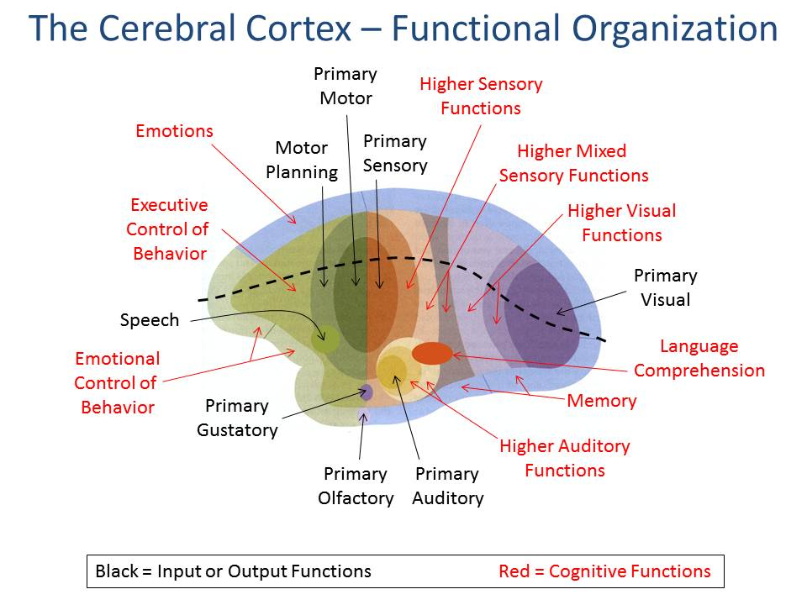
All the cortical areas fall into a few general functional categories (Fig. 8). Areas within a category occupy a discrete, continuous portion of the cortical sheet. Areas that are related functionally occupy neighboring locations.

Sensory information is processed in serial pathways in the cortex. For example, sensory information first arrives in the primary sensory areas from the thalamus. After some processing, the information is passed on to higher order cortical sensory areas of the same modality, where sensory perceptions are generated. Ultimately, the information is passed to still higher order sensory cortex which can integrate information from several modalities; these areas can generate more complex sensory perceptions based on multimodal input.
Fig. 8. Functional areas of the cerebral cortex.

In addition, parallel pathways in each sensory modality pass information into superior (dorsal) and inferior (ventral) association cortex. The superior (dorsal) pathways typically carry spatial and temporal information that is processed in the parietal association areas. The inferior (ventral) pathways carry information representing form and content that is processed in temporal association areas.

Goal-directed motor behavior is controlled mainly in the frontal lobe. Information representing motor behaviors is processed serially, beginning in the rostro-lateral parts of the frontal lobe, where the appropriate behavior is conceived. The information is passed caudally, to the motor planning areas, which translate the behavior into components representing groups of joints and muscles. Ultimately the information is sent to the primary motor cortex which amplifies the excitations appropriately and activates the appropriate groups of lower motor neurons to induce movements.
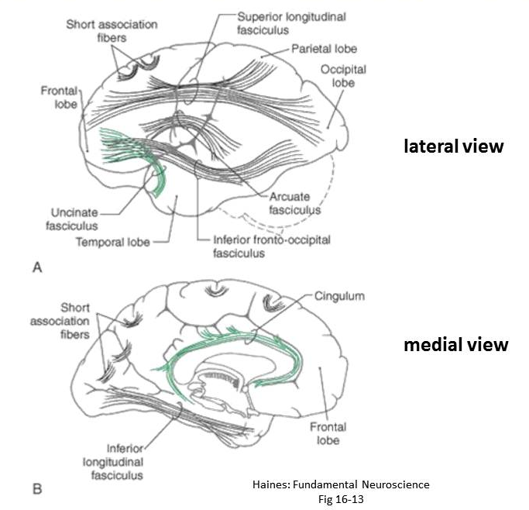
Limbic areas, which surround the corpus callosum, process signals representing the memory and the emotions. Most sensory, motor and association cortex has reciprocal connections with the limbic cortex.

The Cerebral White Matter

The cerebral white matter is located below the cortex. Commissural bundles of fibers connect cortical areas across the two hemispheres. The largest of these is the corpus callosum, which connects the corresponding areas in each hemisphere. Smaller commissural bundles include the anterior and posterior commissures and the hippocampal commissure. The anterior commissure interconnects various parts of the anterior temporal lobes and the frontal lobes. The hippocampal commissure interconnects the two hippocampi. The posterior commissure connects caudal parts of the midbrain reticular formation and the thalamus.
Fig. 9. Cortical association bundles

By contrast, the association bundles connect various cortical areas within the same hemisphere (Fig. 9). The shorter association fibers interconnect cells in adjacent gyri. The longer association fibers interconnect areas of cortex which are distant from one another.

Projection fibers comprise the fibers passing to and from the cortex of each hemisphere from subcortical structures. Most of these fibers are organized into a compact bundle called the internal capsule.

