THE UNIVERSITY OF CONNECTICUT
Systems Neuroscience
2012-2013

The Autonomic Nervous System

Lecture
S. J. Potashner, Ph.D.
(sjp9713@neuron.uchc.edu)

Reading
1. Purves, Chapter 21.
2. This syllabus

Overview

The autonomic nervous system (ANS) is a distinct division of the nervous system. Its main function is to regulate cardiovascular, respiratory, digestive, urinary and reproductive organs, which are the main effectors of homeostasis. In general, it provides motor innervation to smooth and cardiac muscles and glandular epithelium, or structures made up of these tissues. Many authors emphasize the motor components of this system and ignore the sensory components. However, visceral sensory neurons connect the target tissues to the ANS and CNS, and supply sensory information vital to autonomic function. For these reasons, modern descriptions of the ANS are beginning to include the sensory components. The ANS is regulated by a network of structures in the CNS, including the hypothalamus and the brain stem reticular formation (RF).

Neuroanatomy

Divisions of the ANS: Based on differences in anatomy and function, the ANS can be divided into three major subdivisions.
- Sympathetic division – organized to mobilize the body for activity.
- Parasympathetic division – organized for energy conservation.
- Enteric division – organized to control the local functions of the gut.

The Lower Motor Pathway: Fig. 1 compares the lower motor pathways of the somatic (skeletal), sympathetic and parasympathetic systems. In the somatic motor system, the lower (alpha) motor neuron lies in the ventral horn of the spinal cord; its axon travels in the peripheral nerve to synapse with the skeletal muscle.
In the sympathetic and parasympathetic systems, the brain stem or spinal neuron is a premotor neuron. The autonomic lower motor neuron is located outside the CNS in a ganglion and is called a postganglionic cell (Fig. 1). The premotor neuron, often called the preganglionic cell, projects its axon through the peripheral nerve to synapse on the postganglionic cell. In the sympathetic division, the ganglia lie in two locations: paravertebral ganglia are located on the lateral sides of the vertebra and are connected together by a longitudinal sympathetic trunk of nerve tissue; prevertebral ganglia are located anterior to the vertebra on the anterior surface of the abdominal aorta. In the parasympathetic division, the ganglia are near or in the target organs.
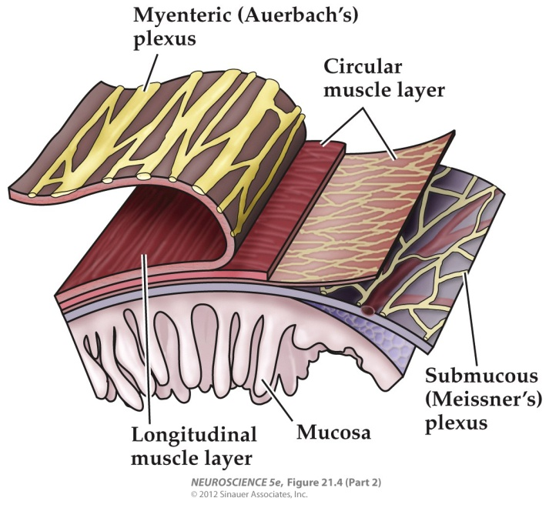
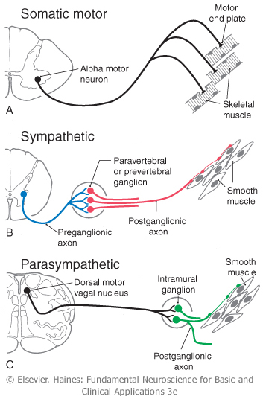
In the enteric division, motor and sensory neurons are distributed in nerve plexuses inside the gut wall (Fig. 2). The myenteric plexus lies between the two smooth muscle layers near the outer surface of the gut wall and controls peristalsis and muscular tone. The submucosal plexus lies below the mucosa and regulates glandular secretions and mediates chemical monitoring.
Fig. 2. Enteric plexuses.
Fig. 1. Lower motor pathways.

Sympathetic Pathways:
- The preganglionic (premotor) neuron cell bodies are found at spinal levels T1 to L2, located in the intermediolateral cell column of the spinal grey matter (Fig. 3, blue). This cell column has a rostral-to-caudal viscerotopic organization (Figs. 3-4). Cells controlling the eye are most rostral, those controlling the heart and lungs are somewhat more caudal, and those controlling the GI tract, bladder and genitalia are the most caudal. The preganglionic axon is myelinated and enters the spinal nerve at the spinal level where the soma is located (Fig. 3). Lateral to the vertebra, the axon leaves the spinal nerve to enter the paravertebral sympathetic trunk via a branch called the white communicating ramus.
Once inside the sympathetic trunk, some preganglionic axons simply synapse on postganglionic neurons in a sympathetic ganglion at the same segmental level as the spinal nerve (Fig. 3 A & D, blue). Others turn in the longitudinal sympathetic trunk to ascend or descend to a ganglion at a different segmental level before synapsing on a postganglionic neuron (Fig. 3 B & D, blue; Fig. 4, blue). Still others turn out of the sympathetic trunk to enter one of the three splanchnic nerves, which transmits the axon anteriorly to one of the prevertebral ganglia in the abdomen (Fig. 3C, blue; Fig. 4, blue).
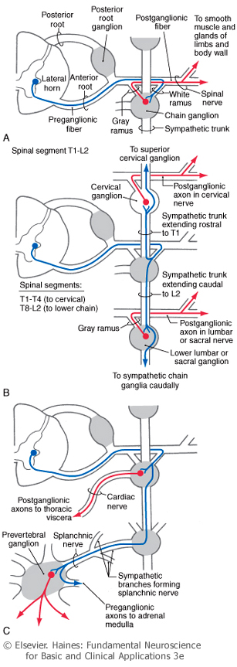
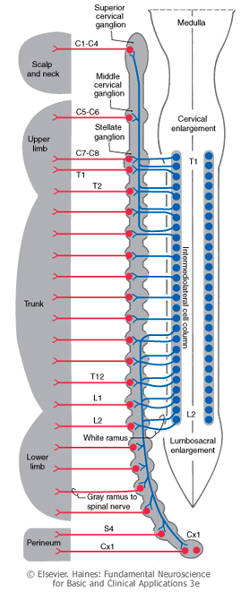
D
Fig. 3. Sympathetic pathways.
- The sympathetic chain on each side of the vertebral column consists of the array of paravertebral ganglia linked together by the sympathetic trunk (Fig. 3). The sympathetic chain extends along the entire length of the vertebral column but the number of ganglia does not correspond to the number of vertebra or spinal nerves. For example, there are usually 3 cervical ganglia, 10-11 thoracic, 3-5 lumbar, and 3-5 sacral on each side, and one midline coccygeal ganglion (Fig. 3D). In many subjects, the inferior (3rd) cervical and 1st thoracic ganglia fuse to form the stellate ganglion.
In all the paravertebral ganglia, some postganglionic neurons project their unmyelinated axons back into the segmental spinal nerve through a branch called the grey communicating ramus (Fig. 3 A & D, red). These fibers innervate the smooth muscle in the blood vessels of the somatic wall, the arrector pili muscles in the skin, and sweat glands in the skin. (These structures receive only sympathetic innervation and lack parasympathetic regulation.) In the cervical and upper thoracic ganglia, other postganglionic neurons project their unmyelinated axons into cervical, cardiac and pulmonary nerves that emerge directly from the ganglia (Fig. 3C, red) and course anteriorly to innervate the vascular smooth muscle of viscera in the thorax, the glandular epithelium of the respiratory structures, smooth muscles of the esophagus and the respiratory airway, and cardiac muscle (Fig. 4). The superior (1st) cervical ganglion innervates the vascular smooth muscle, arrector pili muscles, and sweat glands in the head and neck (Fig. 3D, red; Fig. 4). It also innervates viscera, such as salivary, nasal and lacrimal glands; the pupillary dilator muscles of the eye; and the tarsal (opener) muscles of the eye.
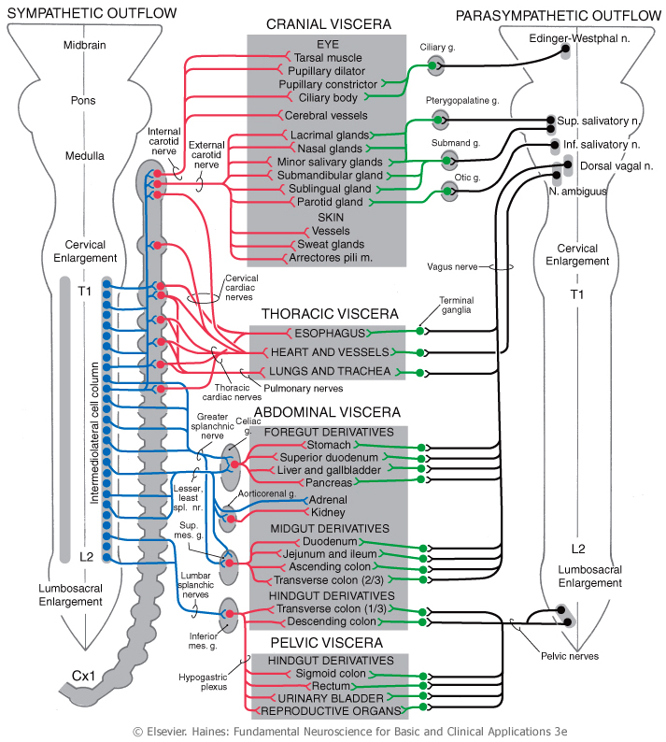
Fig. 4. Sympathetic and parasympathetic pathways to visceral targets.

- The prevertebral ganglia are found on the anterior surface of the abdominal aorta where the major blood vessels emerge to supply the abdominal viscera. The celiac ganglion, located at the origin of the celiac artery, supplies postganglionic axons to foregut structures (listed in Fig. 4). The renal ganglion provides postganglionic fibers to the kidney. The superior mesenteric ganglion innervates midgut structures (Fig. 4). The inferior mesenteric ganglion supplies hindgut and pelvic viscera (Fig. 4).

- Preganglionic neurons (Figs 3-4, blue) employ acetylcholine as a transmitter. Most of the postganglionic neurons (Figs. 3-4, red) employ norepinephrine as a transmitter. However, those innervating sweat glands in the skin and blood vessels in skeletal muscles use acetylcholine. The target cells of sympathetic innervation express a variety of receptor types so that one particular transmitter may have different effects. For example, alpha1 adrenergic receptors on vascular smooth muscle mediate vasoconstriction when activated by norepinephrine, while beta2 adrenergic receptors mediate vasodilation.

Parasympathetic Pathways: Parasympathetic pathways travel in cranial nerves III (oculomotor), VII (facial), IX (glossopharyngeal), and X (vagus), as well as in sacral spinal nerves 2-4. The preganglionic (premotor) and postganglionic neurons and their pathways are illustrated in Fig. 4 and Table 1. Both pre- and postganglionic neurons use acetylcholine as their transmitter. Target organs express various subtypes of the muscarinic cholinergic receptor so that the transmitter can have different effects in various organs. For example, activation of M1 muscarinic receptors in the gut generates peristaltic contractions but activation of M2 receptors in cardiac muscle results in a reduction of heart rate.

TABLE 1. Parasympathetic Pathways.
 | Preganglionic  Neurons | Preganglionic  Axons | Postganglionic  Neurons | Targets | Actions
Oculomotor  (III) | Edinger-Westphal nuc. | Nerve III | Ciliary ganglion | Pupil constrictor | Contraction
Facial  (VII) | Sup. salivatory nuc. | Nerve VII | Pterigopalatine & submandibular ganglia | Lacrimal, nasal, submandibular & sublingual glands | Secretion
Glossopharyngeal  (IX) | Inf. salivatory nuc. | Nerve IX | Otic ganglion | Parotid gland | Secretion
Vagus  (X) | Dor. motor vagal nuc.  Nuc. ambiguus | Nerve X | In target | Heart, great vessels, respiratory system, esophagus, foregut,  midgut | ↓ heart rate, bronchial  constriction  ↑ blood to gut, peristalsis,  secretion
Sacral | Intermedial spinal gray of S2-S4 | S2-S4 | In target | Hindgut, bladder, reproductive organs | Various

Function

Sympathetic Division: Sympathetic responses mobilize the body for activity; they produce energy expenditure, catabolic functions and cardio-pulmonary adjustments for intense activity. For example, a typical sympathetic response may include:
An elevated breathing rate, bronchodilation, an elevated heart rate and blood pressure, to facilitate perfusion of the nervous system and muscles with oxygenated blood; dilation of blood vessels in skeletal muscle increasing the flow of oxygen and energy; constriction of blood vessels in the skin and GI tract to shunt blood flow to the nervous system and skeletal muscles; dilation of pupils in the eyes to improve vision; suppression of digestion in the GI tract; facilitation of glycogenolysis and glucose release from the liver into the blood to supply energy to the nervous system and skeletal muscles; sweating to dissipate heat, so that muscles can function efficiently.

The sympathetic division is organized to produce this array of body-wide responses in a coordinated and adaptive manner, with very short latency and with little or no cognitive evaluation. It is, in fact, a sympathetic program that might be named ‘the emergency program’ or the ‘fight or flight program’. However, not all sympathetic activity is so abrupt and drastic, as there is also continuous, ongoing activity. Even when the emergency program has not been activated, the sympathetic division is never quiescent but always maintains a modest operating level, which is called ‘sympathetic tone’.

Parasympathetic Division: Parasympathetic responses are organized for energy conservation; they reduce energy expenditure and increase energy stores. The parasympathetic program of responses might be named ‘the rest and digest program’. Examples of typical parasympathetic responses may include:
Decreased heart rate and blood pressure; reduced bronchial diameter; dilation of blood vessels in the GI tract; promotion of digestion, absorption of digested nutrients, and peristalsis; increased insulin secretion, and fat and glycogen synthesis and storage; constriction of pupils in the eye to protect the retina from intense light.

Like the sympathetic division, the parasympathetic division is organized to produce this array of responses in a coordinated and adaptive manner, with short latency and little or no cognitive evaluation. There is also continuous, ongoing activity that always maintains a modest operating level, which is called ‘parasympathetic tone’.
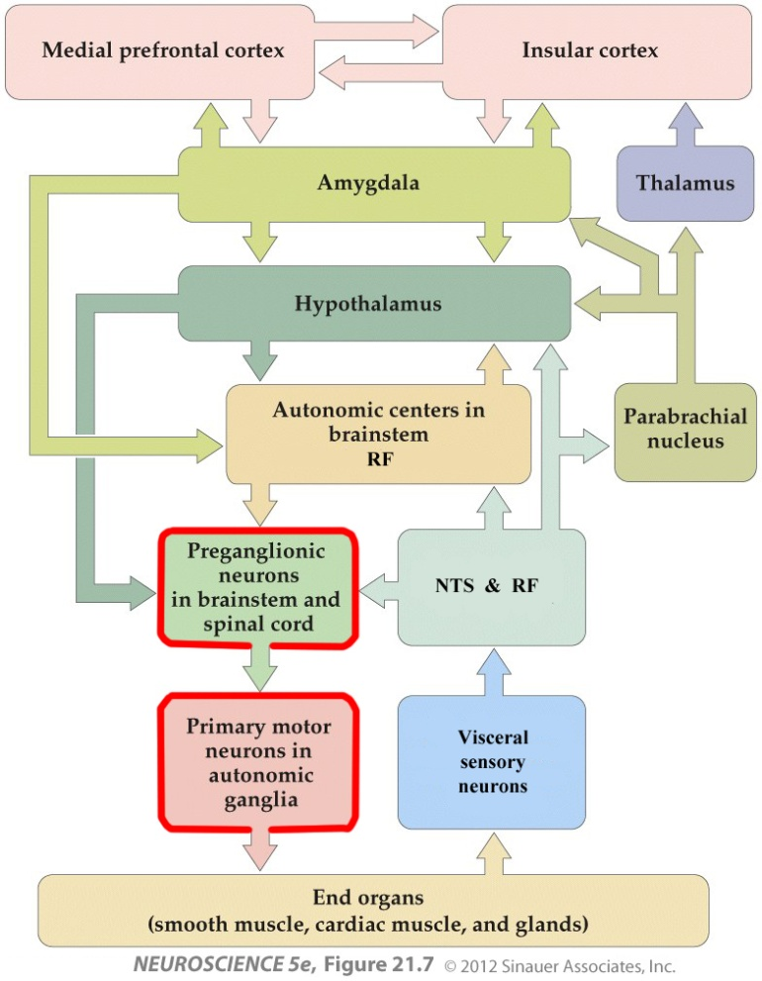
Fig. 5. The central autonomic network.
Central Regulation of the ANS: The ANS is part of an autonomic network which includes many areas of the CNS (Fig. 5). The primary influences on the preganglionic (premotor) autonomic neurons are the hypothalamus and the autonomic centers within the brain stem RF.

Examples of autonomic regulation

The Baroreflex: The baroreflex adjusts heart rate, heart contraction force and blood pressure to insure adequate perfusion of the head and upper body when we change our posture in the Earth’s gravitational field.
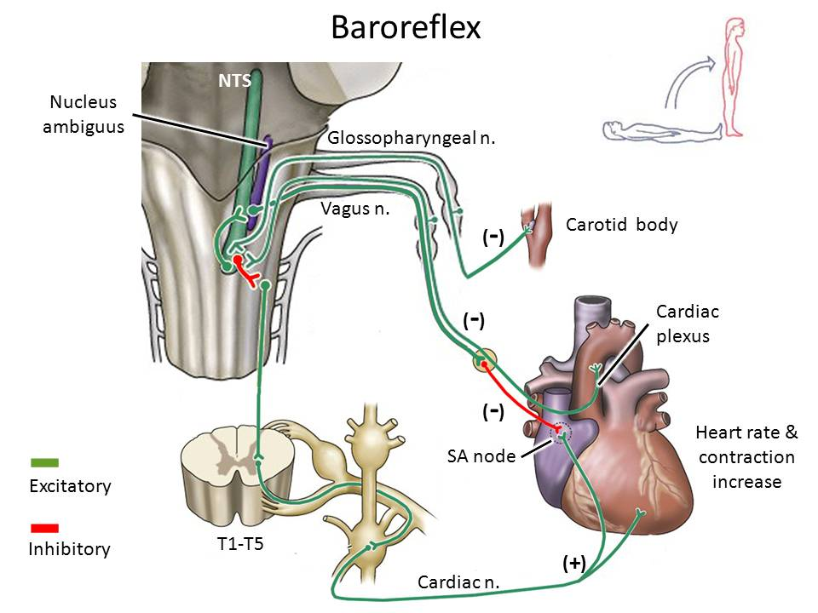
Fig. 6. The baroreflex – movement to an upright position.
When changing abruptly from a horizontal to an upright position (Fig. 6), blood pressure and perfusion of the upper body becomes inadequate. Stretch receptors in the carotid body in the neck and on the great vessels emanating from the heart become deactivated, carrying fewer action potentials and releasing less transmitter onto the cells in the caudal part of the nucleus of the solitary tract (NTS), where they project. The deficit of excitation in the caudal NTS has two consequences.
- The excitatory NTS neuron that projects to the nucleus ambiguous cannot excite the preganglionic parasympathetic vagus neuron. The latter, in turn, does not excite the inhibitory postganglionic parasympathetic neuron lying in the cardiac plexus. This postganglionic parasympathetic neuron, when activated, usually inhibits the SA node, resulting in a slower heart rate. But under the present circumstances, the inhibitory postganglionic parasympathetic neuron is inactive, as it receives little or no excitatory input. The consequence is that the SA node, relieved of inhibition, drives the heart rate faster.

- The inhibitory NTS neuron that projects to the ventral RF in the medulla cannot inhibit the RF cells. These RF cells are usually spontaneously active, generating a high frequency of action potentials. Under the present circumstances, they receive little or no inhibitory input. The result is that they drive excitatory outflow from the sympathetic pre- and postganglionic neurons that project in the cardiac nerves to the heart. This sympathetic excitation induces the SA node to drive the heart rate faster and the heart muscle to contract with more force. These changes in the balance between parasympathetic and sympathetic tone increase blood pressure and the perfusion in the upper body.

When changing quickly from an upright to a horizontal position (Fig. 7), blood pressure in the upper body becomes excessive. Stretch receptors in the carotid body and on the great vessels emanating from the heart become activated, carrying a high frequency of action potentials to the cells in the caudal NTS. This excitation stimulates vagus parasympathetic activity, resulting in the inhibition of the SA node, and inhibits sympathetic outflow along cardiac nerves, resulting in inhibition of the SA node, a slower heart rate and less forceful heart contractions. The consequence is a lower blood pressure.

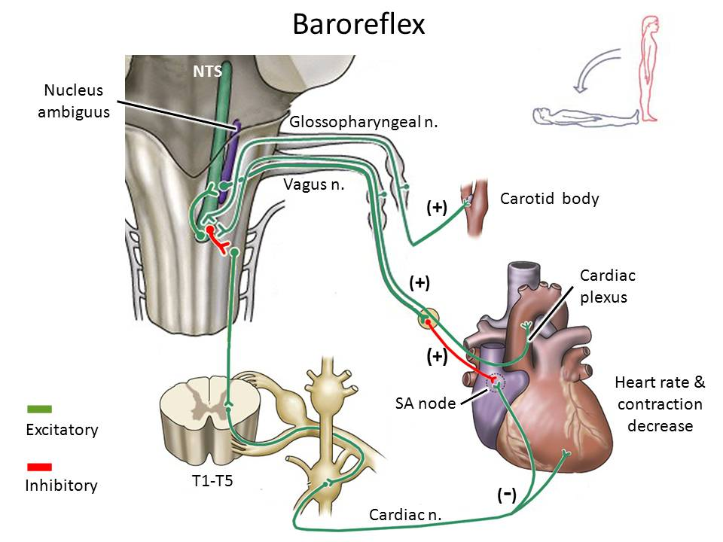
Fig 7. The baroreflex – movement to a horizontal position.
Bladder control: Bladder control involves visceral sensory, autonomic and somatic motor pathways, and is coordinated and monitored by nuclei in the pons and the medial frontal cortex.
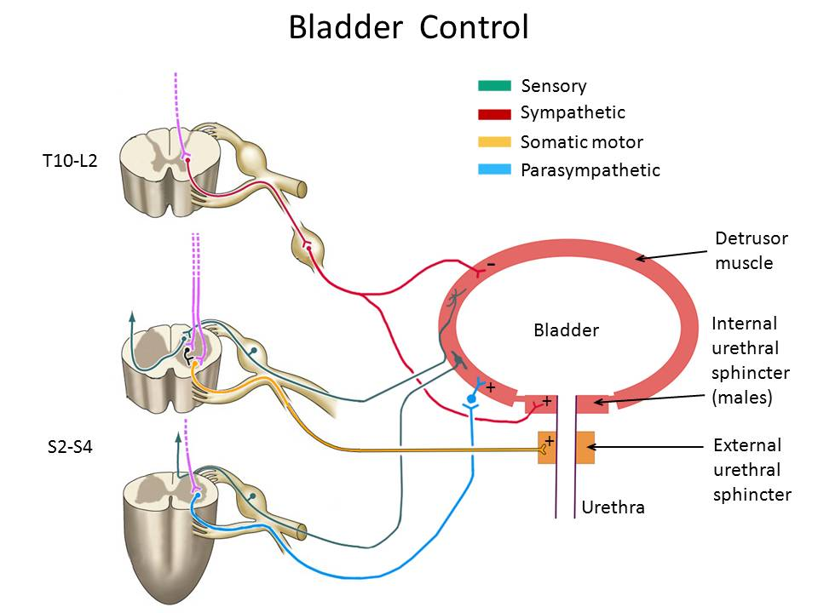
- When the bladder is filling, sympathetic tone and somatic motor tone predominate. Stretch receptors in the bladder wall become activated and signal to second order interneurons in the spinal grey (Fig. 8, green). The spinal interneurons organize these signals to stimulate preganglionic sympathetic neurons and inhibit preganglionic parasympathetic neurons. Sympathetic activity (Fig. 8, red) results in the relaxation of the detrusor muscle and the contraction of the internal urethral sphincter muscle which closes the urethra. These actions allow the bladder to fill.
Fig. 8. Bladder control. Pluses = muscle contraction; minus = muscle relaxation.

Stretch receptor signals are also carried rostrally in the anterolateral system (ALS) and the dorsal column-medial lemniscus pathway (Fig. 8, green arrows) to visceral sensory cortex and eventually reach the medial prefrontal cortex. From there, they are sent caudally to the periaqueductal gray matter (PAG) in the midbrain and the bladder control nuclei in the pontine RF. The reticular nuclei provide descending projections that regulate the activity of the autonomic preganglionic neurons in the intermediolateral spinal grey and the somatic motor neurons in the spinal ventral horn (Fig. 8, purple). During bladder filling, the pontine RF stimulates the somatic motor neurons that innervate the external urethral sphincter (Fig. 8, yellow), which is a skeletal muscle. The consequence is that the external sphincter is contracted and closes the urethra.

- When the bladder is full, parasympathetic tone predominates. The pontine reticular formation stimulates the spinal parasympathetic preganglionic neurons; parasympathetic activity induces contraction of the detrusor muscle in the bladder wall (Fig. 8, blue). At the same time, the descending reticular fibers inhibit sympathetic activity, which suppresses the contraction of the internal urethral sphincter and the relaxation of the detrusor muscle. The descending reticular fibers also inhibit (Fig. 8, black) the somatic motor neurons that innervate the external urethral sphincter, which allows the sphincter to relax. The consequence is that pressure inside the bladder is increased and the urethral tube is open, allowing micturition to occur.

Figures

Figs. 1, 3, 4. Haines D.E. Fundamental Neuroscience for Basic and Clinical Applications, 3rd Edition, Elsevier, Philadelphia PA, 2006.

Figs. 2, 5-8. Purves D. et al., Neuroscience, 4th Edition, Sinauer, Sunderland MA, 2008. Note: Figs. 5-8 have been modified and reconstructed by SJP.

Additional reading

Haines D.E. Fundamental Neuroscience for Basic and Clinical Applications, 3rd Edition, Elsevier, Philadelphia PA, 2006. Chapter 29, pp. 473-485.

