THE UNIVERSITY OF CONNECTICUT
Systems Neuroscience
2012-2013

Anatomy Of The Basal Ganglia

Lecture
S. J. Potashner, Ph.D.
(sjp9713@neuron.uchc.edu)

Reading
1. Purves, Chapter 18.
2. This syllabus

Overview

The basal ganglia are a group of nuclei located near the center of each hemisphere. They are part of the forebrain, lie anterior and lateral to the rostral part of the thalamus, and are intimately involved in cortical functions. The basal ganglia operate to solve a basic behavioral problem; we cannot do two things simultaneously, we must choose one. Stated in terms of motor behaviors, one could say that several actions that use the same muscles in different ways cannot occur at the same time, so one action must be chosen. When the basal ganglia function properly, they select the best action from a repertoire of actions. The best action is usually the one which has provided a rewarding outcome previously and is predicted to provide a rewarding outcome in the present circumstances. The basal ganglia execute their function mainly by controlling excitation in the thalamus, the cerebral cortex and several groups of pre-motor neurons in the brain stem.

Functions

- The basal ganglia operate to produce action selection. They facilitate the most effective motor, cognitive and emotional behaviors for the prevailing circumstances and they suppress other behaviors. They tend to facilitate behaviors which have had and/or are predicted to have rewarding (positive) outcomes.

- In addition, such actions which are often repeated in a sequence are bound (chunked) together into a behavior unit. Similarly, behavior units that are often repeated in a sequence are bound together into a longer, more complex behavior. This binding permits a complex behavior to occur without the need for selecting each component step.

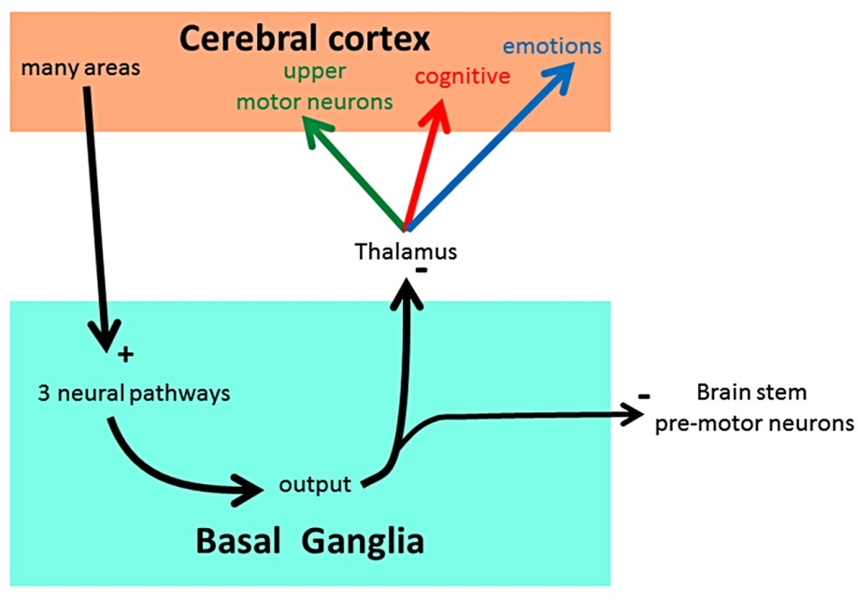
The basic signaling plan (Fig. 1)

Most input signals are excitatory and come from the cerebral cortex and the thalamus before passing through the basal ganglia via three main pathways. Signals emerging from the basal ganglia are inhibitory and are projected to the thalamus and to premotor neurons in the brain stem. Thus, basal ganglia output suppresses excitation in the cerebral cortex via the thalamus and in brain stem pre-motor neurons. In other words, the basal ganglia output normally suppresses actions, thoughts and emotions.
Fig. 1. Signaling scheme.
To make a particular action occur, part of the output of the basal ganglia must be suppressed. This depends on the simultaneous arrival of three types of signals in the basal ganglia. First, signals that represent the actions which are available. Second, sensory, cognitive and emotional signals that represent the current circumstances and the memories associated with them. Third, signals that represent the saliency or urgency of the various available actions.

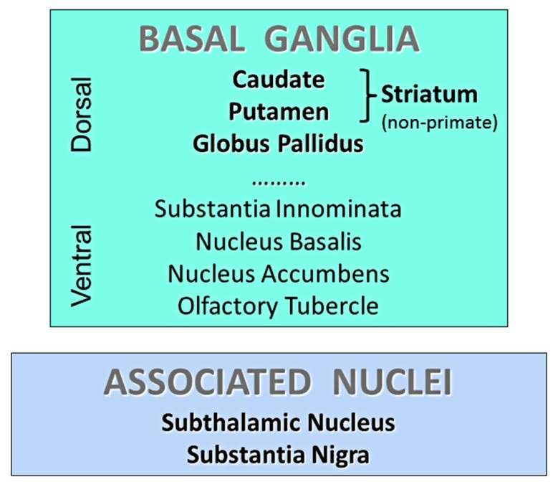
Neuroanatomy

Location: The basal ganglia are located near the center of the forebrain; they are surrounded by the cortical white matter. The original definition of the basal ganglia includes seven nuclei, which were grouped into the dorsal and ventral subregions (Fig. 2). This lecture focuses on the dorsal subregion which is concerned mainly with motor and some cognitive functions; the ventral subregion is involved mainly with emotional and cognitive functions.
- Caudate (Fig. 3 & Fig. 4A-D, green). The caudate nucleus lies medial to the internal capsule and is shaped like a comma with a very long, C-shaped tail. The rostral part of the nucleus is enlarged into a head region that bulges medially from the lateral wall of the rostral part of the lateral ventricle; it lies rostral to the thalamus. The tapering body of the caudate arches superiorly and caudally but remains fixed into the lateral wall of the lateral ventricle. The tail of the caudate continues to arch caudally, superior to the thalamus, but curves to follow the lateral wall of the lateral ventricle into the temporal lobe. The tail ends in the rostral part of the temporal lobe, just caudal to the amygdala.
Fig. 2. Basal ganglia and associated nuclei.
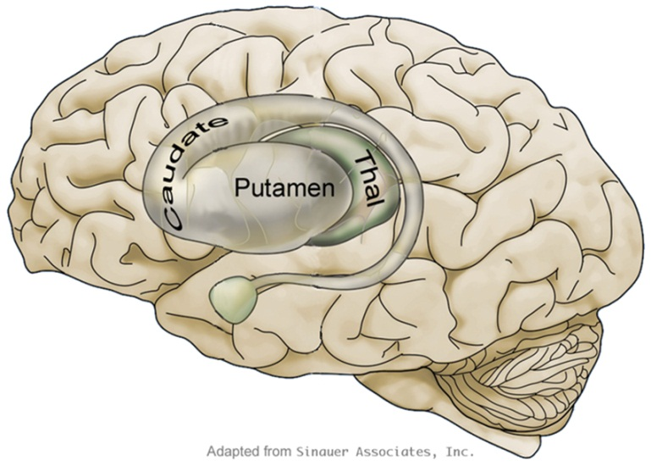
- Putamen (Fig. 3 & Fig. 4A-C, green). The putamen is an oval shaped plate that lies lateral to the internal capsule and medial to the insular cortex. It is swollen in size rostrally, where it lies rostral to the thalamus, and becomes thinner caudally, where it lies lateral to the thalamus.
Fig. 3. Lateral view of basal ganglia.
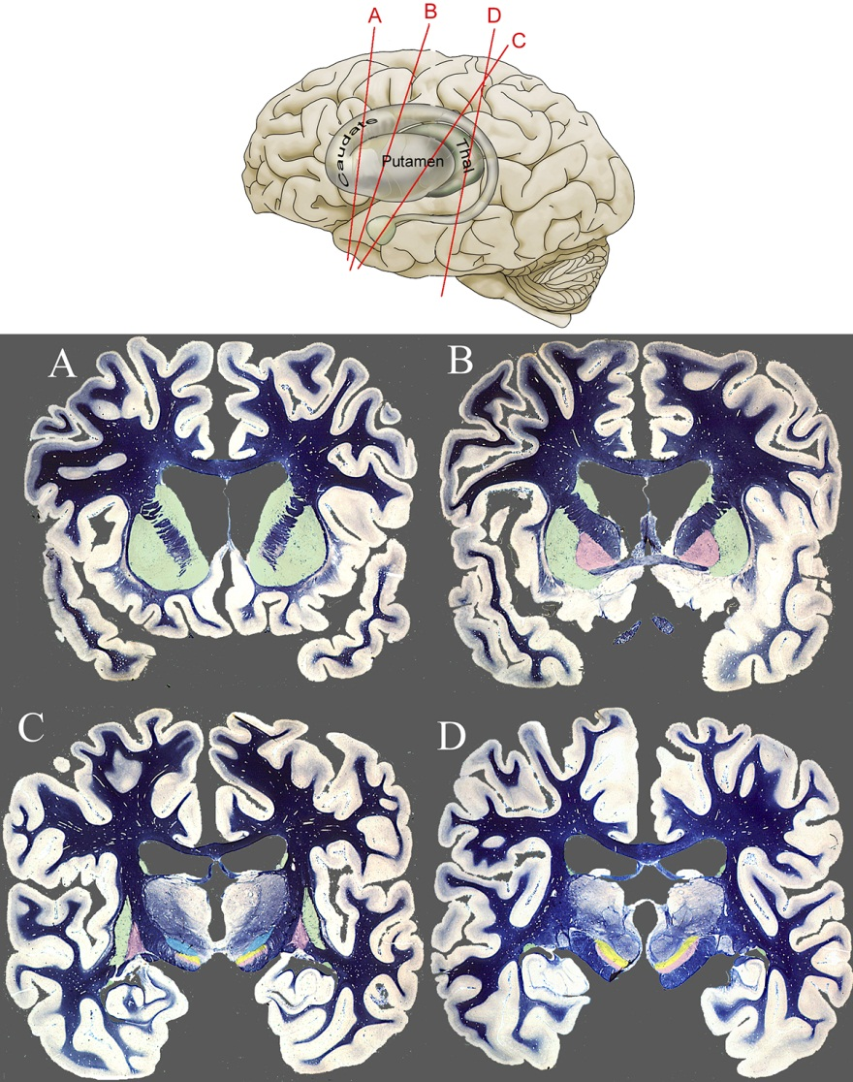
- Globus pallidus (Fig. 4B-C, pink). The globus pallidus lies medial to the putamen and lateral to the internal capsule. It is swollen in size rostrally, where it lies rostral to the thalamus, and becomes thinner caudally, where it lies lateral to the thalamus. The globus pallidus can be divided into a medial internal segment (GPi) and a lateral external (GPe) segment; the GPi has a dense collection of fibers coursing through it. Both the GPe and the GPi contain GABAergic neurons. The GABAergic projections emanating from the GPi form a major output pathway from the basal ganglia.
Fig. 4. Locations of the basal ganglia in coronal sections.

Two other nuclei are associated with the basal ganglia.
- The subthalamic nucleus (STN) (Fig. 4C, blue) lies inferior to the ventral lateral nucleus (VL) of the thalamus, superior to the substantia nigra (SN) and antero-lateral to the red nucleus.

- The substantia nigra (SN) lies in the ventral midbrain, just posterior to the cerebral peduncles. It can be divided into dorsal and ventral parts.
- The dorsal part, the pars compacta (SNc) (Fig. 4C-D, yellow), contains a very dense array of dopaminergic neurons that project their axons to the caudate and putamen (striatum). This projection is usually called the nigro-striatal dopaminergic pathway.

- The ventral part, the pars reticulata (SNr) (Fig. 4C-D, pink), contains a network of GABAergic neurons. Like the GPi, the GABAergic projections emanating from the SNr form a major output pathway from the basal ganglia.

Neural pathways: There are many pathways to and through the basal ganglia. This lecture focuses only on those that are closely related to motor functions, while pathways related to cognitive and emotional functions are largely ignored. We begin with the input and output pathways and then consider those passing through the basal ganglia and its associated nuclei.
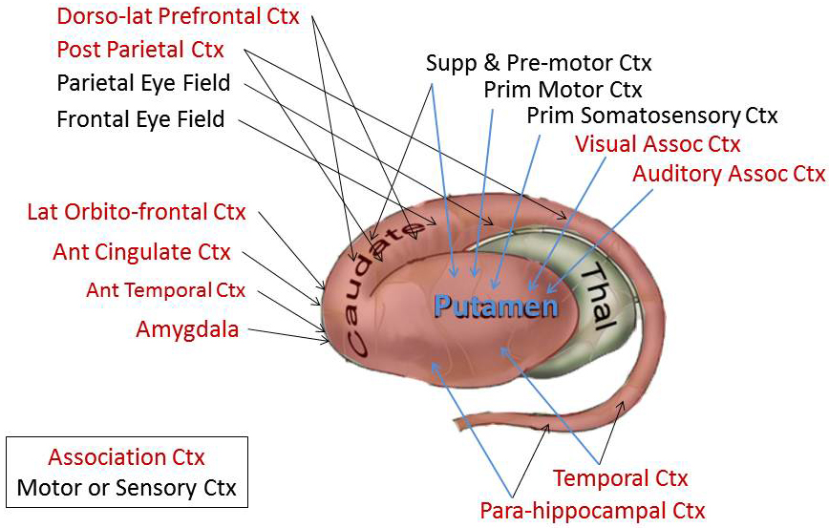
- Input pathways: Most input axons originate in the cerebral cortex (Fig. 5) and the thalamus, and synapse in the caudate and/or putamen (striatum) on the dendritic spines of medium spiny neurons. Medium spiny neurons comprise up to 97% of striatal cells, depending upon the species. The cortical input is massive, excitatory, glutamatergic and derived from the entire cortical mantle (including the motor and somatosensory areas which are the focus of this series of lectures). It provides signals representing motor, sensory, cognitive and limbic information. The thalamic input consists of a more modest number of fibers but the synapses they make in the striatum are roughly similar in number to those made by the cortical inputs. The thalamic input comes mainly from the interlaminar nuclei, bringing information about arousal and wakefulness. The remaining thalamic input comes from many of the other thalamic nuclei, bringing information about the external world as well as cognitive and emotional activity.
Fig. 5. Input pathways to the striatum.
The motor and somatosensory areas of the cortex project axons mainly into the rostral and central parts of the putamen, which represent the processing of motor-related signals (Fig. 5, black text). Immediately superior to this area, within the caudal body and superior tail of the caudate nucleus, is another motor area which receives cortical projections from the frontal and parietal eye fields in the cerebral cortex, and processes signals relating to eye and head movement behaviors. Apart from these areas, other parts of the striatum receive input projections from other sensory areas of the cerebral cortex and/or from the association cortices (Fig. 5, red text).

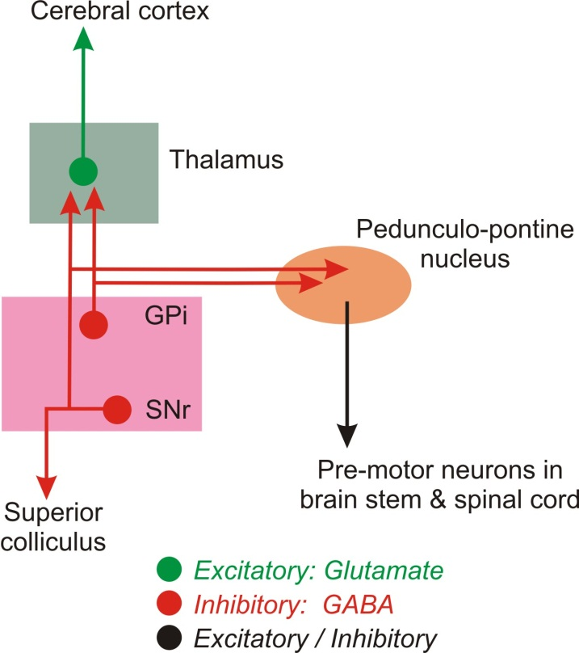
- Output pathways: Output signals emanate from the GPi and the SNr (Fig. 6). The cells providing these output projections are all GABAergic and tonically active, with a mean firing rate in excess of 40 Hz. The output, therefore, can be considered to be vigorous, continuous and inhibitory.
Fig. 6. Output pathways of the basal ganglia.
The GPi axons project mainly to various nuclei of the thalamus which, in turn, project thalamic axons mainly into the anterior two-thirds of the cerebral cortex. They also project to the pedunculo-pontine nucleus (PPN) of the reticular formation. The PPN contains pre-motor neurons that project to the pre-motor interneurons of the brain stem and spinal cord via the reticulo-spinal tracts.
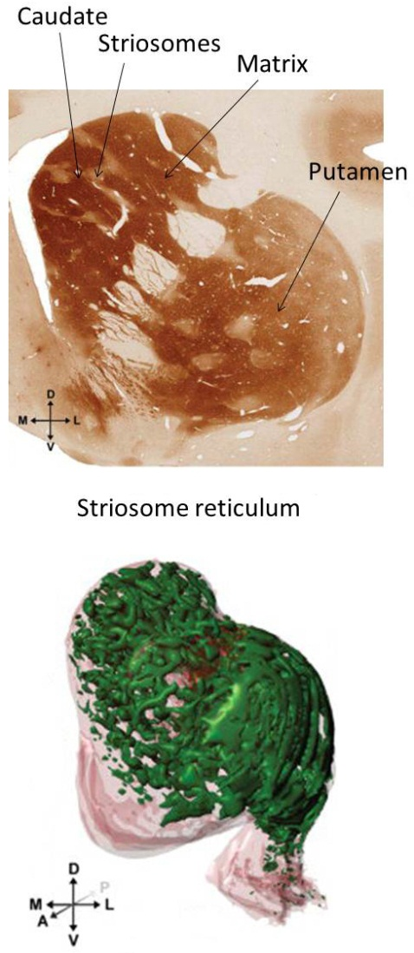
The SNr axons project to several thalamic nuclei, particularly those that send axons to the frontal eye fields of the cerebral cortex. SNr axons also project to the superior colliculus (SC) and the PPN of the reticular formation. The SC contains pre-motor neurons that help to control eye and head movements.
Therefore, the GPi and SNr output suppresses excitations in the thalamus, the cerebral cortex (via thalamic axons) and the pre-motor neurons of the SC and PPN. At rest, this inhibitory output from the basal ganglia tends to suppress movement, thought and emotion etc. To facilitate excitations in groups of neurons that will make selected actions, thoughts or emotions occur, some of the inhibitory output of the GPi and/or SNr must be suppressed for a period of time.

- Pathways through the basal ganglia. These pathways provide the neural substrates that enable the basal ganglia to determine which action, thought or emotion will be facilitated, via a temporary suppression of its inhibitory output, or suppressed.
- Striatal neuroanatomy: The striatum is organized into two main cellular compartments; the striosomes and the matrix (Fig. 7).
Fig. 7. Striatal anatomy. (J. Comp. Neurol. 514: 507–517, 2009)
- The striosomes form a lattice-like, connected reticulum in both the caudate and putamen (Fig. 7, bottom, green) that occupies approximately 15% of their
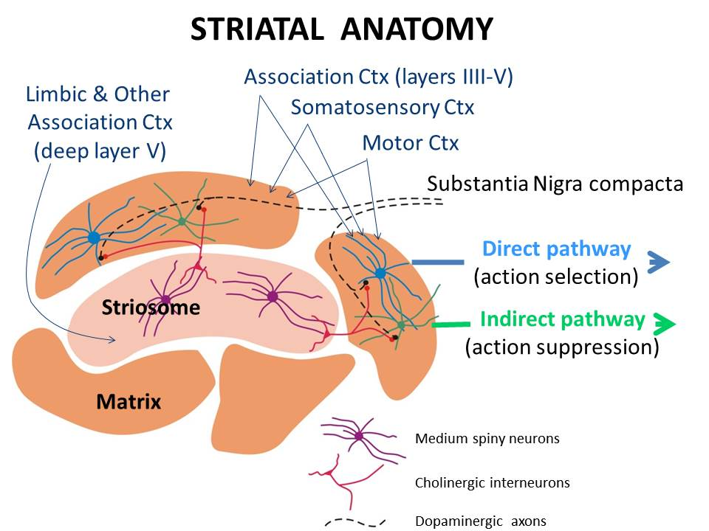
volume. In the caudate, however, striosomes are sparse in the body and absent from the tail. The striosomes are composed of GABAergic medium spiny neurons (Fig. 8, purple). Tonically active cholinergic interneurons (TANs) lie at or near the striosome border (Fig. 8, red).
The dendrites of the GABAergic medium spines neurons receive excitatory glutamatergic synapses from cortical cells in the limbic and other association cortices. Signals on these axons are believed to represent predictions of the saliency (importance) or urgency of actions based on past experience and present conditions. If the prediction of saliency or urgency is high (ie high frequency of action potentials), the GABAergic medium spiny neurons become depolarized and fire a high frequency of action potentials, and completely inhibit the firing of the TANs for a short period of time (Fig. 8, red). By contrast, if saliency is not particularly high (ie moderate or low frequency of action potentials), the firing rate of the medium spiny neurons is moderate to low and that of the TANs is maintained or reduced slightly.
Fig. 8. Cellular anatomy of the striatum. (Modified from Frontiers in Human Neuroscience, 2011, vol 5, article 47. Epub May 27.)

- The matrix compartment surrounds the striosomes and occupies approximately 85% of the striatum. The matrix contains GABAergic medium spiny neurons. The matrix is divided into groups of cells (matrix groups) that are thought to represent particular actions.
In each matrix group, the dendrites of the medium spiny neurons (Fig. 8, Matrix, blue & green) receive excitatory glutamatergic synapses from cells in layers III - V in the motor and somatosensory cortices and from cells in layers III to superficial layer V in association cortices. Axons from topographically related areas in these regions of cortex converge on groups of medium spiny neurons in the matrix group. The cortical axons are believed to carry signals representing current and available actions, as well as sensory, cognitive and emotional signals representing current circumstances and their associated memories. These signals converge on groups of matrix cells that represent various actions and bias the medium spiny neurons toward excitation.
The full excitation of cells in a matrix group also depends on two additional inputs; dopaminergic axons from the SNc (Fig. 8, black) and TANs from the striosome (Fig. 8, red). SNc axons are activated by cortico-nigral fibers that carry signals representing the predicted reward that may be realized from the action. The temporary suppression of TAN output represents the saliency or urgency of the action.
- SNc axons synapse on or near the dendrites of the medium spiny neurons. Some of the medium spiny neurons in each matrix group have dopamine D1 receptors on their dendrites and project their axons into the ‘direct’ pathway to the GPi and SNr (Fig. 8, blue). Dopamine release and binding to D1 receptors leads to activation of this pathway, which suppresses the inhibitory output of the GPi and SNr and contributes to the selection and facilitation of the action represented by the cells in the matrix group. When there is little or no dopamine release, the direct pathway is inactive.
The remaining medium spiny neurons in each matrix group have dopamine D2 receptors and contribute their axons to the ‘indirect’ pathway to the GPi and SNr (Fig. 8, green). When there is little or no dopamine release, this pathway is active and augments the inhibitory output from the GPi and SNr, thus suppressing the actions represented by the cells in the matrix group. Dopamine release and binding to the D2 receptors suppresses activity in this pathway. Dopamine release (ie predicted greater reward), therefore, facilitates action selection, while little or no dopamine release (ie predicted little or no reward) suppresses the action.

- The cholinergic TANs project their axons from the striosome into the matrix to synapse on the dopaminergic synaptic endings of the SNc axons (Fig. 8, red). ACh release from TAN axonal endings is thought to act on the SNc axonal endings to suppress dopamine release (Fig. 8, black). Therefore, a striosome signal representing high saliency or urgency that precipitates a temporary but complete suppression of TAN activity will remove the TAN inhibition of dopamine release for a period of time. During this period, dopamine release, if signaled by a predicted reward, can activate the direct pathway (action selection) and suppress the indirect pathway (action suppression). By contrast, a striosome signal representing little or no saliency or urgency will not interrupt the TAN output and dopamine release will be suppressed. Then, the direct pathway (action selection) would be inactive and the indirect pathway (action suppression) would be active.

- In summary, if a high saliency signal and a signal representing a large reward arrive simultaneously in the matrix group, the action represented by the cells in the matrix group will be selected. If one or both of these signals is weak or absent, the action would be suppressed.

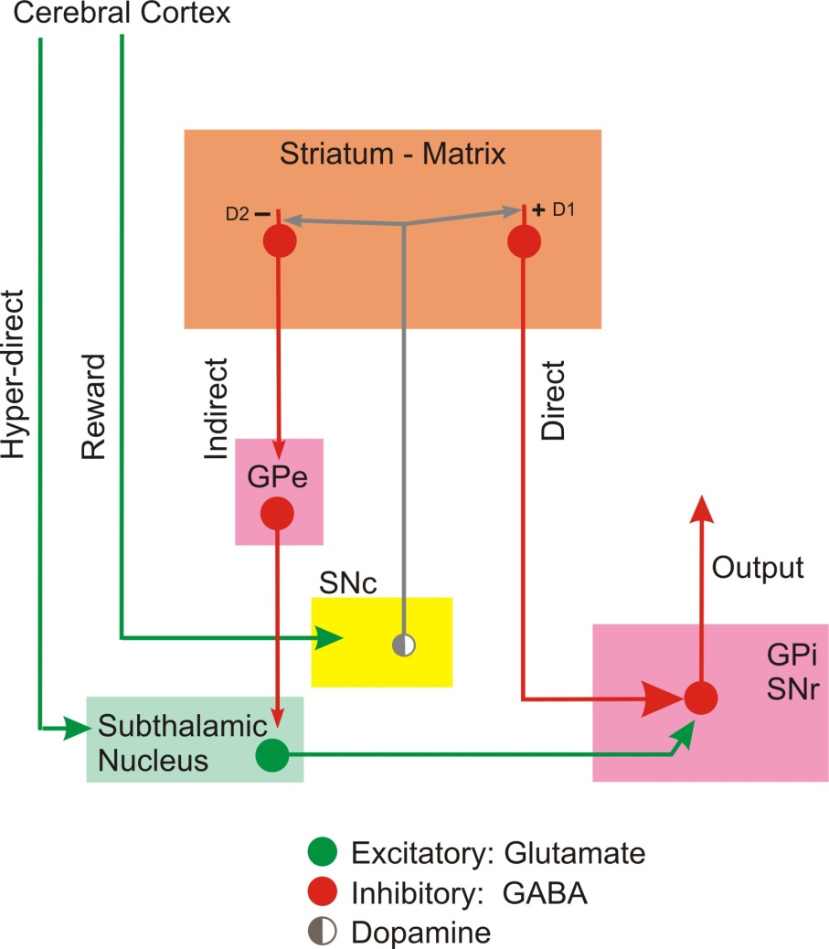
- The direct pathway (Fig. 9, Direct): In each matrix group, one set of medium spiny neurons project directly to and synapse on the output cells in the GPi and SNr. The axons of these medium spiny neurons converge on a smaller number of output neurons in the GPi and SNr. The striatal cells are GABAergic, inhibitory and normally quiescent, so that it requires considerable simultaneous input activity from glutamatergic cortical and dopaminergic SNc axons to bring them to discharge. When they do discharge, they suppress the output of GPi and SNr cells on which they synapse. Therefore, the direct pathway facilitates action selection.

- The indirect pathway (Fig. 9, Indirect): In each matrix group, one set of medium spiny neurons project indirectly to the output cells in the GPi and SNr. Striatal medium spiny neurons project their axons to synapse on cells in the GPe. GPe cells project their axons to synapse on cells in the STN which, in turn, projects axons to the GPi and SNr. In this three-neuron pathway, the first cell, the striatal medium spiny neuron, is GABAergic, and inhibitory. The second cell, the GPe neuron, is GABAergic, inhibitory and tonically active. The third cell, the STN neuron, is glutamatergic and excitatory. Exciting the striatal neuron suppresses the inhibition of the (excitatory) STN cells which can then facilitate stronger inhibitory output from the GPi and SNr. Therefore, the indirect pathway facilitates action suppression.
Fig. 9. Pathways through the basal ganglia

- The reward pathway (Fig. 9): Cells in the orbito-frontal and medial prefrontal cortex project axons and make synapses in the SNc. This cortico-nigral projection is glutamatergic, excitatory and thought to carry signals representing the predicted rewards that will be realized from various actions. SNc neurons, in turn, project into the matrix of the striatum and release dopamine from their axonal endings.
Since the matrix medium spiny neurons of the direct pathway have dopamine D1 receptors on their dendrites, released dopamine will facilitate the activation of these cells and the selection of an action. The matrix medium spiny neurons of the indirect pathway have dopamine D2 receptors on their dendrites; released dopamine inactivates these cells resulting in strong inhibition of the (excitatory) STN by axons from the GPe, and suppression of the excitatory STN drive on the GPi and SNr. This effect on the indirect pathway also facilitates action selection (because it inactivates action suppression).
When prevailing circumstances associate an action with the prediction of a small or negligible reward, the reward pathway is relatively inactive and there is little or no release of dopamine in the striatal matrix group. In this instance, the direct pathway is inactive (ie no action selection) but the medium spiny neuron at the beginning of the indirect pathway becomes activated. This suppresses the inhibitory GPe projection to the STN, resulting in increased STN excitation and activity. The axonal endings of STN cells then release glutamate in the GPi and SNr to facilitate greater inhibitory output. Thus, signals representing modest or negligible rewards for an action facilitate action suppression.

- The hyper-direct pathway (Fig. 9, Hyper-direct): Cells from many cortical areas project axons directly to the STN to provide a constant, low level of excitation to STN cells. In addition, bursts of cortical excitation are used to drive STN cells to interrupt or stop actions.

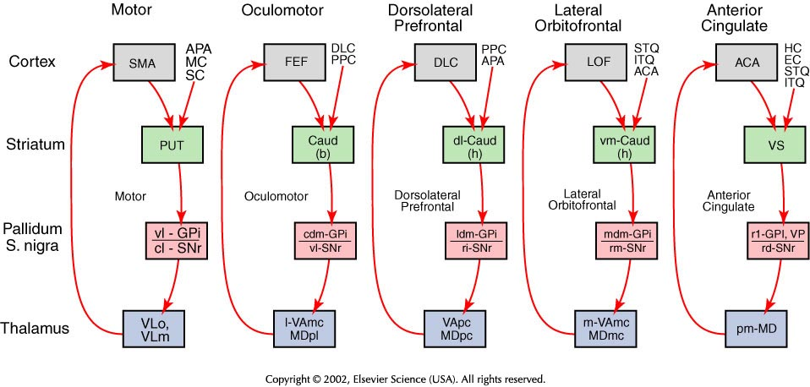
- Segregated parallel basal ganglia pathways (loops): These pathways begin in various regions of the cerebral cortex and have a neuroanatomic plan that is similar to the motor pathway described above (Fig. 10). The two motor pathways are vital for selecting motor actions and behaviors. The lateral orbitofrontal and anterior cingulate pathways are instrumental for selecting limbic functions. The dorsolateral prefrontal pathway is involved in selection of cognitive functions.
Fig. 10. Segregated basal ganglia pathways. ACA ant cingulate area; APA arcuate premotor area; CAUD b body, h head; DLC dorsolat prefrontal ctx; EC entorhinal ctx; FEF frontal eye fields; HC hippocampal ctx; ITQ Inf temporal gyrus; LOF lat orbitofrontal ctx; MC motor ctx; MD medial dorsal thalamus; PPC post parietal ctx; PUT putamen; SC somatosensory ctx; SMA suppelmentary motor ctx; STQ sup tempotal gyrus; VA ventral anterior thalamus; VL ventral lateral thalamus; VP ventral pallidum; VS ventral striatum; cl caudolateral; cdm caudal dorsomedial; l lateral; ldm lateral dorsomedial; m medial; mdm medial dorsomedial;; pm posteromedial; rd rostrodorsal; rl rostrolateral; rm rostromedial; vm ventromedial; vl ventrolateral.

